

Introduction to

Static Analysis Using

SolidWorks Simulation

®

Radostina V. Petrova

Introduction to

Static Analysis Using

SolidWorks Simulation®

## CHAPTER 3

|  |
| --- |
| ***DEVELOPMENT OF***  ***A FINITE ELEMENT***  ***MODEL OF A BODY***  ***(PRO CESSOR STAGE)*** |

***3.1 HOW DOES FINITE ELEMENT ANALYSIS WORK?***

The core of the **finite element analysis (FEA)** is to divide the solid body model

(Figure 3.1a) into a lot of small pieces, with simple shapes, called **finite elements (FEs)**

(Figure 3.1b). They are connected at common points called **nodes**. The **FE method (FEM)** predicts the behaviour of the model, based on the equations describing the behaviour of each FE as well as the inter-relations among them and their interaction with the ambient environment.

The very process of dividing the model into FEs is called **meshing**, and the result of that division is a mesh of FEs. Meshing is crucial for the final success of the FEA. While meshing a solid body model, SW Simulation generates two types of FEs (Figure 3.2):

* **Linear solid element** (Figure 3.2a) is a linear tetrahedral FE. It is defined by four nodes at its corners that are connected through six straight edges. As the displacement functions along these edges are linear functions, the element is also called an **FE of the first order**. Using this type of FE or FEs, the program generates a **draft quality mesh**.
* **Parabolic solid element** (Figure 3.2b) is a parabolic tetrahedral FE. It is defined by 10 nodes, situated at the corners as well as at the mid-points of the edges. The connecting edges are parabolic curves. The displacement functions along the FE edges are parabolic functions as well; thus, these FEs are also known as **secondorder FEs**. Using them, the program generates a **high-quality mesh**.

The use of linear or parabolic solid elements, as well as their size, strongly influences the accuracy of the analysis. This impact will be discussed in detail later.

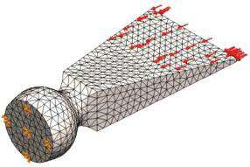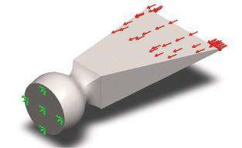

(

a

)

(

b

)

### Fig u r e 3.1

*Meshing a solid body. (a) Solid body m odel; (b) FE m odel.*

(

a

)

(

b

)

### Figure 3.2

*Solid FEs (SW Simulation on-line help). (a) Linear solid elem ent; (b) parabolic solid elem ent.*

The software was also operated with 2D and 1D FEs. Their applications will be studied further when shells and structures of beams are analysed.

We explained the main idea of the FEM, that is, the object to be divided in small pieces called FEs, which are connected to each other by nodes. The very process of dividing the object into FEs is called meshing, and the result is a mesh of FEs.

|  |
| --- |
| In this section, we learned   * What are finite elements and what are nodes * What meshing is * What are the two types of 3D FEs, which are supported by the software and what are the main differences between them |

***3.2 WHAT ARE THE FEs AND THE MESH?***

**Meshing** can be started either through the command bar or through the analysis tree (Figure 3.3). To start meshing through the command bar, you must right click the **Run** icon () and choose **Create Mesh** ( ) in the pop-down menu (Figure 3.3a). If you decide to use the **Mesh** command ( ) at the **SW Simulation** analysis tree, you will have access to a more detailed pop-up menu (Figure 3.3b).



Starting the meshing through the **SW Simulation** analysis tree provides access to more options with this procedure. We can see that the commands through which we can control the meshing process are divided into a few groups.

(a)

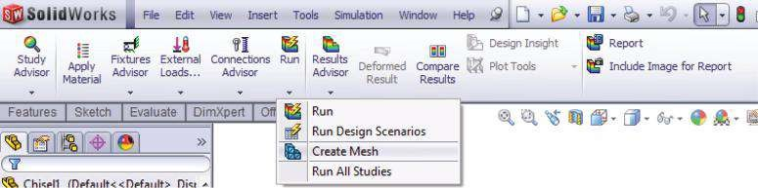

(b)

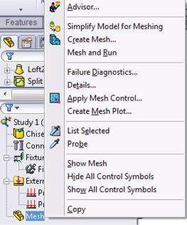

### Figure 3.3

*Starting the mesh generation. (a) From the command bar; (b) from the analysis tree.*

The first group unites the commands that help the generation of the mesh. They are the following:

**• Simplify model for meshing** (, Figure 3.3b). Another way to activate this utility is (Figure 3.4)

Tools→Find/Modify→Simplify…

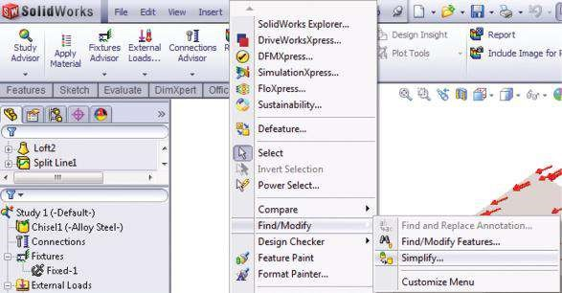

### Figure 3.4

*Starting the Sim plify comm and through the SW comm and bar.*

This utility is helpful when there is an internal calculation of “insignificant volume” based on the size of a part or assembly. The selected features below that volume are suppressed.

The **Simplify** utility can be applied to fillets, chamfers or holes to extrude and revolve to more than one of them simultaneously. After selecting the impacted **Features** (Figure 3.5a and 1, Figure 3.5b), the **Simplification factor** should be set (2, Figure 3.5b). This will change the insignificant volume.

The **Simplification factor** is used differently according to the selected method (Figure 3.5c): the **Feature Parameter** (3a, Figure 3.5c) or the **Volume Based** (3b, Figure 3.5c), yet it always affects the actual volume of the model or of the preselected feature. The **Feature Parameter** identifies the feature for simplification regarding *P* < *a* (*V*min * )*S* , where *P* is the value of the main feature parameter (e.g. for a hole this is the diameter and for a fillet this is the fillet radius); *V*min is the minimum volume of the body associated with the feature, and *S* is the value of the **Simplification factor**. The **Volume Based** method identifies the feature for simplification under the condition *V* < *CV* * *S*, where *V* is the feature volume and *CV* is the volume of the part or of the assembly. For an assembly file, the option **Ignore features affecting assembly mates** can be picked so those features that would cause mate failures are not suppressed.

After clicking **Find Now** (4, Figure 3.5d), a tree of features with insignificant volumes is displayed in the **Results** section (5, Figure 3.5e). When **Create derived configurations** is unsuppressed, the simplified features can be added to a different configuration selected under **Configurations** (6, Figure. 3.5f). Further, this configuration can be renamed in the **Name** box and is updated automatically.

**• Create Mesh** (): This command can be activated either from the **SW**

**Simulation** toolbar (Figure 3.3a) or from the **SW Simulation** analysis tree

(Figure 3.3b). Then the **Mesh** property manager opens (Figures 3.6 and 3.8),

(a) (b) (c)

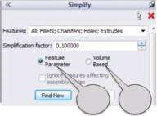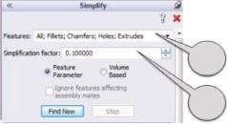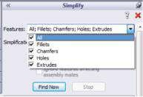

1

2

3

a

3

b

(d) (e) (f)

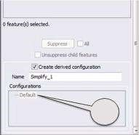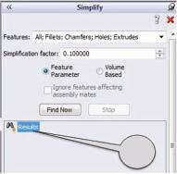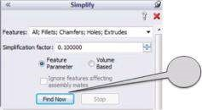

4

5

6

### Fig u r e 3.5

*Sim plifying the m odel. (a) Features supported by Sim plify utility; (b) introducing the value of the Sim plification factor; (c) selecting the m ethod of sim plification; (d) starting the process of sim plification; (e) Results section, where all simplified features are displayed; (f) creation of a new configuration.*

(a) (b) (c)

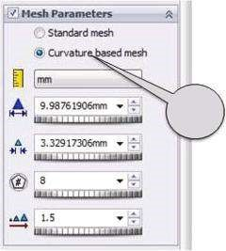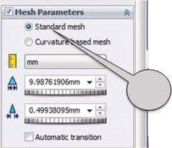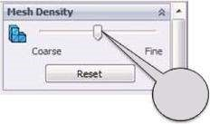

1

2

a

2

b

### Figure 3.6

*Mesh property manager – Mesh Density and Mesh Parameters sub-windows. (a) Mesh Density option; (b) standard mesh parameters; (c) curvature-based mesh parameters.*

and all options of the mesh should be input. Of course, there are some options when values are set by default.

* The first to be introduced are the parameters regarding the **Mesh Density** (Figure 3.6a). The slider (1, Figure 3.6a) enables easy simultaneous variations of the size and tolerance of the FEs. By default, it is situated somewhere in the middle of the line. If we move the slider to the left (**Coarse side**), the size of the FEs increases twofold compared to the initial data. Moving the slider to the right (**Fine side**) decreases the size of the FEs and increases the mesh density. As a result, the mesh becomes finer when moving the slider to the right. The global element size can be decreased up to half of its default value.
* The next step is to introduce the **Mesh Parameters**. The program offers two types of mesh – a **Standard mesh** (2a, Figure 3.6b) or a **Curvature-based mesh** (2b, Figure 3.6c). The **Standard mesh** activates the Voronoi– Delaunay meshing scheme, whereas the **Curvature-based mesh** automatically enables the use of FEs of higher order in higher-curvature areas. After that, the **units** of the mesh size and tolerance have to be set (, Figure 3.6b and c).
* Both the **Global size** option (, Figure 3.6b) and the **Tolerance** option (, Figure 3.6b) are available only for a **Standard mesh**. Through the **Global size**, the program suggests a default value (corresponding to the default position of the slider in the **Mesh Density** sub-window) of the FEs, based on the model volume and the surface area. By default, the tolerance value is 5% of the global element size. If the distance between two neighbour nodes is smaller than that, the nodes are merged unless otherwise specified in the contact conditions. The upper limit of the tolerance is 30% of the global element size. Sometimes, adjusting the tolerance helps in solving problems related to the mesh creation. When **Automatic transition** is checked (Figure 3.6b), the program automatically applies mesh control to all fine details of the model. Thus, the generated mesh is finer at the area with small features, and the number of FEs is higher compared to when this option is unchecked.
* All further discussed options are available only for **Curvature-based mesh**. They are **Maximum element size** (, Figure 3.6c), which is used for boundaries with the lowest curvature; **Minimum element size** (, Figure 3.6c), which is used for boundaries with the highest curvature; and **Min number of elements in a circle** (, Figure 3.6c), which specifies the number of elements in a circle (Figure 3.7). Thus, if the value of **Min number elements** is set to 8, eight triangles can form an octagon with a side of *h*, which is to be inscribed in an imaginary circle with radius *r*. The length of the side of the octagon is *h ≈ r*α, where α is the corresponding central angle; in this case α = 2π/8. This option is effective if the size *h* is in between the values of the **Maximum element size** and the **Minimum element size**. The **Element size growth ratio** (, Figure 3.6c) specifies the global element size growth ratio starting from regions of high curvatures in all directions.
* The next sub-window in the **Mesh** property manager includes the **Advanced** options (Figure 3.8a). **Jacobian points** (Figure 3.8a) is an option that is available for high-quality mesh only, that is, with FEs of second order. The mid-side nodes of these FEs wrap around the geometry of high curvature regions much better than the linear FEs. This option sets the number of integration points to be used in checking the distortion level of tetrahedral elements. The **Jacobian check** can be based on 4, 16, and 29 **Gaussian points** or **At Nodes**. Basically, there is no real hard evidence that using any more than the default amount of points for the Jacobian check makes the mesh much better; however, the higher values increase the resolution of the computation of the Jacobian value, without any substantial increase in time of mesh generation.

r

α

*h*

### Fig u r e 3.7

*How to determine the element size (SW Simulation on-line help).*

(a) (b)

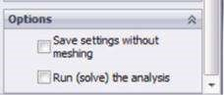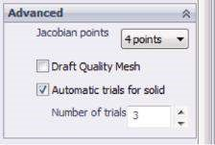

### Figure 3.8

*Mesh property manager – Advanced and Options sub-windows. (a) Advanced options; (b) Options.*

* If the **Draft Quality Mesh** (Figure 3.8a) is checked, 4 corner nodes for each 3D FE and 3 corner nodes for each 2D FE will be used. This option is recommended for models without any curvature surfaces or for quicker calculations.
* The **Automatic Trials for Solid** (Figure 3.8a) is an option available for standard mesh only. If it is checked, the meshing algorithm remeshes the model automatically in case of failure of the previous trial, using smaller global elements with a reduced ratio and tolerance equal to 0.8 for each trial. The option **Number of trials** (Figure 3.8a) sets the maximum number of mesh trials.
* For assembled solid body models, the option **Remesh failed parts with incompatible** mesh is also available. It specifies that the incompatible meshing should be used for bonded bodies if the compatible meshing has failed (to be explained in more detail later).
* The last sub-window in the **Mesh** property manager is **Options** (Figure 3.8b). There are two accessible options that can be kept as they are selected or deselected: **Save settings without meshing** and **Run (solve) analysis**.
* The quality parameters for all FEs can be plotted through the **Create Mesh Plot** command (Figure 3.3b), which has the options **Mesh**, **Aspect ratio** and **Jacobian** (Figure 3.9). The **Aspect ratio** is the ratio of the longest normal to the shortest normal in an FE, where the normal is dropped from the vertex node to the opposite face of the element, that is, the **Aspect ratio** measures how ‘stretched out’ the element is. It is recommended that the aspect ratio be under about 5 for structural analysis.
* **Mesh and Run** (Figure 3.3b) meshes the model by using the input mesh settings and automatically runs an analysis after that.

The second group of commands in the **Mesh** pop-down menu (Figure 3.3b) unites commands that help in checking the quality of the generated mesh. They have to be activated after the mesh generation; otherwise, they provide no information.

* **Failure diagnostics** (Figure 3.3b) enlists () and highlights all the components that failed to be meshed. These can be components (), faces () or edges (). **Failure diagnostics** also can be done through **Simulation advisor**. Then the results appears at the **Simulation advisor** on the right side of the working area (1, Figure 3.10a).
* **Details** (Figure 3.3b) automatically opens a window with the entire data related to the just generated mesh (Figure 3.10b). You can see the name of the study, the type and properties of the FEs, the number of nodes and elements, the **Aspect ratio**, the **Jacobian** and the time to complete the mesh. Thus, you

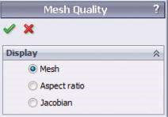

### Fig u r e 3.9

*Creating of mesh quality plots.*

(a) (b) (c)

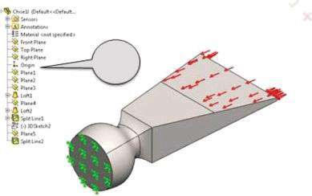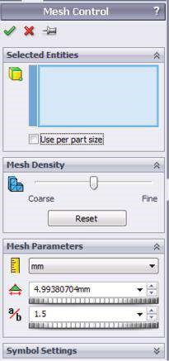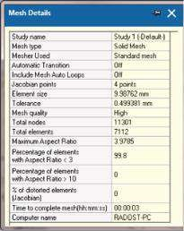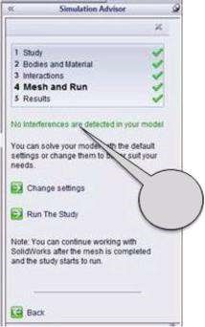

(

d

)

1

2

### Fig u r e 3.10

*Checking the quality of the generated m esh. (a) Failure diagnostics; (b) Mesh Details; (c) Mesh Control property manager; (d) Floating Feature Manager design tree.*

can judge the quality of the mesh and decide whether to leave it as it is or to re-mesh the model.

* **Apply Mesh Control** (, Figure 3.3b). It is known that the smaller the size of the FE, the higher the accuracy of the calculation. Yet, this results in more time for the program to find the solution. Thus, it is recommended to look for a balance between the size of the FEs and the precision needed. This command enables the user to use FEs of different size within one and the same model. The **Mesh Control** property manager controls the size of the FEs, denoted by *e*, and the growth ratio, denoted by *r*. It can be applied to a selected geometric entity, including a vertex, point, edge, face or any other component. The size of the elements increases, radiating the selected entities, according to the law *e*,

*e* * *r*, *e* * *r* 2, *e* * *r* 3,…., *e* * *r n*. The mesh radiates from vertices to edges, from edges to faces, from faces to components and from a component to connected components. The entities can be selected by directly clicking on them at the graphics area or from the floating **Feature Manager design tree** (Figure 3.10d). After the selection, they are coloured in blue, and their signatures automatically appear in the blue window **Selected Entities** (, Figure 3.10c). If the **Use per part size** is checked, the mesh size is calculated based on the individual part size. After selecting the entities, the **Mesh Density** has to be introduced using the slider in the corresponding window. By default, the program calculates the optimum size of the controlled elements based on their volume and sets the slider in the middle of the range. By moving it to the left, the element size is increased twofold, while moving it to the right, decreases the size up to a half. Additionally, the properties of the mesh can be adjusted through the **Mesh Parameters** window. **Units** (), **Element size** () and **Ratio** (), which sets the ratio between the element size in two neighbouring layers, can be input.

* **Create Mesh Plot** (Figure 3.3b) has been discussed in detail in the previous item (Figure 3.9).
* **List Selected** () and **Probe** () commands open one and the same **Probe** **Result** window (Figure 3.11), where the program displays the node or the element numbers, and the global coordinates of the nodes or of the element centres.
* **At location** (Figure 3.11a) displays the results for individual nodes or elements that are picked in the **Graphics area**.
* **On selected entity** (Figure 3.11b) displays the results for all nodes or elements on the selected entities (faces, edges or vertices).
* **Distance** (Figure 3.11c) measures the distance between every two nodes, selected in the **Graphics area**.
* The next three commands, **Hide Mesh, Hide All Control Symbols** and **Show All Control Symbols**, adjust the visualisation of the meshed model in the **Graphics area** and do not influence the properties of the mesh.

Finally you must remember that the right meshing is crucial for the accuracy of the analysis. By default, the mesh consists of one type of FEs, unless otherwise specified. The generated mesh based on global element size and local mesh control provides the optimal ratio precision to computer time.

(a) (b) (c)

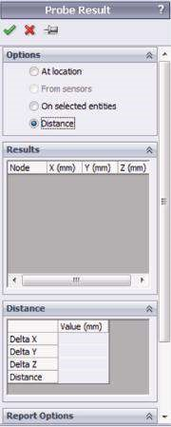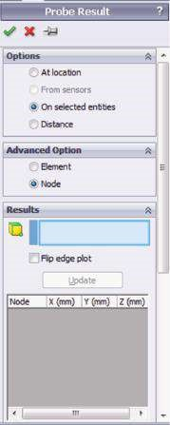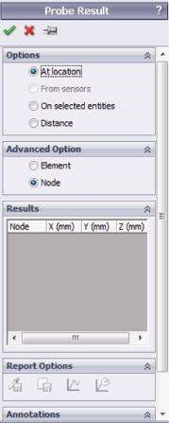

### Fig u r e 3.11

*Probe Result. (a) At location; (b) on selected entities; (c) distance.*

We studied the different mesh types applied to solid body models and how to set the main properties of the mesh, including the maximal and the minimal element sizes. We commented on the main differences between the standard and the curvature-based mesh, as well as how to check the quality of the created mesh. We briefly mentioned what is provided by the program option of Mesh Control, enabling the use of denser meshes in vulnerable areas.

|  |
| --- |
| In this section, we learned   * Both types of mesh provided by the program: standard and curvature-based mesh * The mesh parameters and their impact on the created mesh * How to control the mesh density varying the maximal element size * The Mesh control as an option to better the mesh quality * Some ways to control the mesh quality * List selection and probe commands |

### 3.3 MESHING OF THE ANALYSED BODY

It has been decided to analyse the chisel loaded by two pressure loads, that is, **Scenario 2** from Chapter 2.

We have already introduced the material, the fixtures and the loads to the geometrical model of the chisel. The next step is to create the mesh, that is, to complete the transformation of the model of the solid body into an FE model. To start meshing procedure:

Mesh (right click) →Create Mesh…()

Further,

* We assume the **Mesh density** to be the default, that is, the slider to be situated in the middle of the range (1, Figure 3.12a).
* **Standard mesh** is preferred as there are no entities of high curvature in the model. Hence, we set the options of the **Mesh parameters** sub-window (Figure 3.12b) as follows: check the **Standard mesh** (2a, Figure 3.12b); set **Size of the elements** to 10 mm (2b, Figure 3.12b) and the **ratio** to 0.5 (2c, Figure 3.12b). Finally, we check the **Automatic transition** to activate the mesh control.
* The advanced properties of the mesh are defined through the **Advanced** subwindow of the **Mesh** property manager (Figure 3.12c). They are as follows: **Jacobian** is equal to the highest possible value for that program, that is, 29 (3a, Figure 3.12c); **Automatic trials for solid** is checked (3b, Figure 3.12c) and the **Number of trials** is limited to 3 (3c, Figure 3.12c).
* Check **Run (solve) the analysis** in the **Options** sub-window (4, Figure 3.12d).
* Click **OK** to save the mesh settings, to start the meshing of the object and to run the analysis (5, Figure 3.12d).

Before going further, we can verify the quality of the mesh. This step is not mandatory but is recommended:

Mesh (right click)→Details

(a) (b)

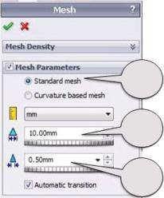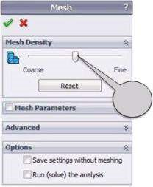

1

2

a

2

b

2

c

(c) (d)

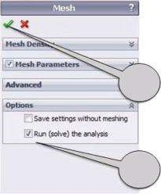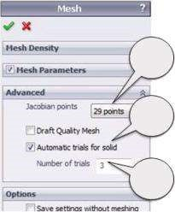

3

a

3

b

3

c

4

5

#### Fig u r e 3.12

*Create m esh. (a) Adjusting m esh density; (b) setting m esh param eters; (c) input of the advanced values; (d) finalising the mesh generation and running the analysis.*

A window with the details of the FE model appears (Figure 3.13a). This is a mesh of linear solid FEs. The number of elements is 7298, and the number of nodes is 11579 (approximately). For your model, it can vary slightly depending on the software mathematical algorithms. Even more, if we re-mesh the model, some of these data could be changed.

The next command from the pop-down **Mesh** menu is

Mesh (right click) →Create Mesh Plot

which starts the **Mesh quality** property manager, which itself provides the following options:

* *Mesh –* generates the plot of the mesh (Figure 3.13b).
* *Aspect ratio –* shows the aspect ratio values over the entire model (Figure

3.13c). Its maximum is 3.74 at the cutting edge of the chisel.

* *Jac obian –* shows the Jacobian values over the entire model (Figure 3.13d). All FEs are well generated, and there are no Jacobian values higher than 2.18.

Consequently, the solid mesh is well generated and will provide accurate results.

(a)(b)

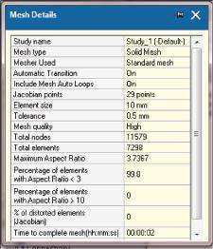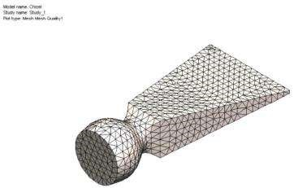

(c) (d)

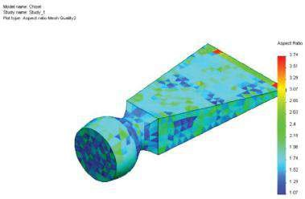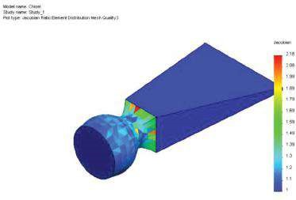

#### Fig u r e 3.13

*Verification of m esh quality. (a) Mesh details; (b) plot the m esh; (c) aspect ratio distribution; (d) Jacobian values distribution.*

We meshed the studied chisel, applying a standard mesh with an FE maximal size of 10 mm and a tolerance of 0.5 mm. We provided all data to assess the quality of the created mesh and concluded that, based on the percentage of the Aspect ratio values smaller than 3 and the percentage of distorted elements, the mesh is well generated and does not need further modification.

|  |
| --- |
| In this section, we practiced our knowledge of creating a mesh and meshed the chisel using linear solid FEs. We learned   * How to obtain current data about the number of FEs and nodes * That the percentages of the Aspect ratio and distorted FEs can be used as a criterion of mesh quality * The necessary computer time to generate the mesh |

### 3.4 RUNNING THE FEA

Finally, it is time to say something about the actual mathematical solution of the problem. We have already discussed the solvers built into the software.

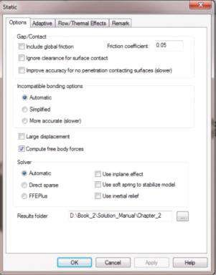

#### Fig u r e 3.14

*Adjusting the properties (the options) of the analysis solver.*

The properties (options, features, characteristics) of the analysis solver are set at the pre-processor stage, when the study properties are defined. Yet, if necessary, it can be changed at this stage. For our analysis, the Automatic option for selecting the solver is checked (Figure 3.14):

Name of the analysis in the SW Simulation analysis tree (right click) →Properties→

Static→Options→Solver →Automatic→OK

The most important thing at that stage of the analysis is the passive involvement of the user. This significantly reduces the possibility of numerical mistakes; however, it could multiply the impact of the mistakes made during the development of the CAD model or during the pre-processor stage, as well as during the mesh creation.

Additionally, we will discuss briefly the calculation workflow for performing a static linear analysis:

* Based on the input data (geometry, material properties, boundary conditions, etc.), the program performs all necessary mathematical equations. As a result, it calculates the displacement components (translational and rotational) of each node.
* Based on the obtained displacement values, the program calculates the strain components as a ratio of the change to the initial value of the length.
* Finally, based on the calculated strain results and Hook’s law, the program calculates the stresses. During the first run, the stresses are calculated at special points, called **Gaussian points**, located inside the elements, in a way that provides optimal numerical results. After that, the results are extrapolated to the nodes of each element. Thus, some different values can appear in a node that is common for a few elements. This is a consequence of the basics of the FEM as a method for approximate numerical calculations. The program presents the stress results in two totally different ways: **element mode** – when the program averages the stress values of all nodes that belong to the element; and **node mode** – when the program averages the stress values of nodes from all elements that share a common node. While the second mode provides a more fluent stress diagram, the first mode is recommended for checking whether the density of the mesh is appropriate. If the stress diagram in the element mode is fluent, then the mesh density is the right one; otherwise, a finer mesh could improve the resolution.

To run the analysis, we can use any of these three command paths:

* SW Simulation command bar→Run( , Figure 3.15a)
* SW Simulation analysis tree→Mesh( or , right click) →Mesh and Run(Figure 3.15b)



* SW Simulation analysis tree→Name of the study(right click) → Run(, Figure 3.15c)

While the calculation is running, the **Study manager** appears (Figure 3.16b). This provides information about the memory usage, elapsed time and reached percentage of the calculation process (18.2%). Additionally, the numbers of degrees of freedom (33,978), of nodes (11,579) and of elements (7298) are shown. The number of degrees of freedom is equal to the number of the searched displacement components, that is, to the number of equations in the solved linear system.

In Figure 3.15, the **Current task** (Stress Reaction Calculation) and its level of completion (99%) are given. The **Convergence plot** is also provided (Figure 3.16a).

**Solver parameters** are shown in Figure 3.16c. They can be changed during the calculation. For example, to improve the accuracy, **Input stopping threshold** can be decreased. If there are calculation problems and the converging process is too slow, either the value of the **Input stopping threshold** can be increased or the **Input Maximum number of iterations for the iterative solver** can be decreased, or both.

The next stage is systematisation, visualisation and analysis of the results, that is, the post-processor stage.

(a) (b)

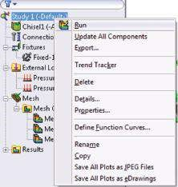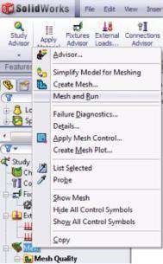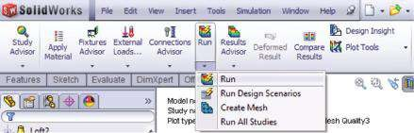

(

c

)

#### Fig u r e 3.15

*Running the analysis. (a) From the comm and bar; (b) from the analysis tree – I version; (c) from the analysis tree – II version.*

(a) (b)

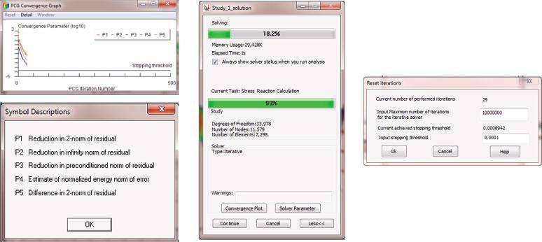

(

c

)

#### Fig u r e 3.16

*Analysis windows. (a) Convergence plot; (b) study window; (c) solver parameters.*

We studied the workflow of the run analysis. We discussed how to assess the feedback provided by the Study manager and how to re-define during the calculations the convergence criteria, if necessary.

|  |
| --- |
| In this section, we learned   * How to run the analysis * How to re-define the used solver * How to modify the convergence options if necessary * How to make the calculations run quicker, reducing the accuracy of the analysis |

## CHAPTER 4

|  |
| --- |
| ***VISUALISING AND***  ***SYSTEMATISING THE RESULTS OF FEA***  ***(POST- PROCESSOR STAGE)*** |

### 4.1 SETTING THE ANALYSIS AND THE RESULTS PREFERENCES

Anytime before starting the analysis, we can set the preferences that “tell” the program how to visualise the obtained results. Otherwise, it uses the default settings. All analysis preferences, including the visualisation of the results, are set in the **Options** property manager. It is activated through the path

Simulation →Options (Figure 4.1a)

The **General System Options** include information about the type of the displayed massages; the quality of the load and fixture symbols – wireframe or shaded; the colours of the mesh; whether to start or not the **Simulation Advisor**; whether to hide or not the excluded components from the analysis; and the font properties (Figure. 4.1b).

As far as the visualisation of the results is concerned, the **Result plots** buttons (Figure 4.1c) can either be selected or not. The choice affects all result plots. There are five options to consider:

* **Dynamic plot update** – it enables automatic updates of the plots as the parameters that control the plots’ appearance are modified. It is recommended to switch this option off to improve performance of viewing results for large models.
* **List result quantities in higher precision** – it enables the results to be listed with up to 16-digit precision.

(a) (b)

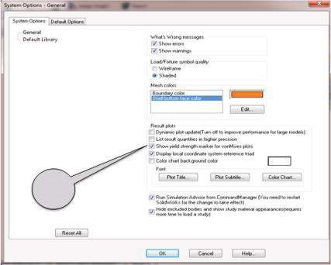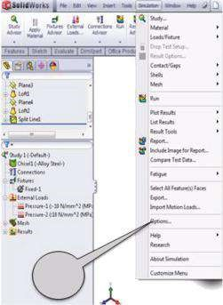

1

2

(c)

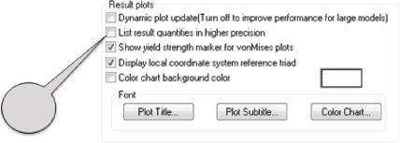

3

#### Figure 4.1

*SW analysis options. (a) Starting Options property manager through the command bar; (b) System Options property manager; (c) Result plots sub-window.*

* **Show yield strength marker for von Mises plots** – when selected, the location of the material yield strength on the plot legend is marked with a red arrow.
* **Display local coordinate system reference triad** – it displays the local coordinate system reference triad at the lower right corner of the graphics area.
* **Color chart background color** – sets the background colour for the plot legend.

There are some options in the **Default Options** window that influence the entire analysis.

* **Units** (Figure 4.2a) – the user can choose among the following systems: **SI**, **English** or **metric**. The SI unit system will be used for all exercises in this book (1a, Figure 4.2a). After that, the basic units for **Length/Displacement**, **Temperature**, **Angular velocity** and **Pressure/Stress** are defined (1b,

Figure 4.2a).

* **Load/Fixture** (Figure 4.2b) – the user defines the size (2a, Figure 4.2b) and the colour (2b, Figure 4.2b) of the used symbols and can choose to select or not the preview option (2c, Figure 4.2b).
* **Mesh** (Figure 4.2c) – defines the quality of the mesh – **Draft** or **High quality** as well as the **Jacobian** points (3a, Figure 4.2c). Further, the mesh settings are set (3b, Figure 4.2c). The influence of these settings on the accuracy of the

(a) (b)

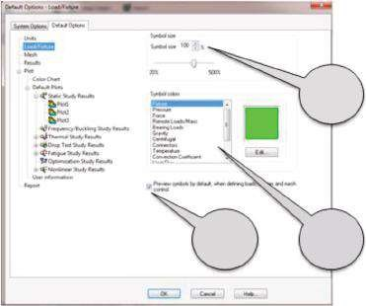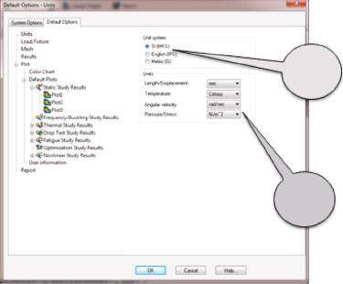

1

a

1

b

2

a

2

b

2

c

(c) (d)

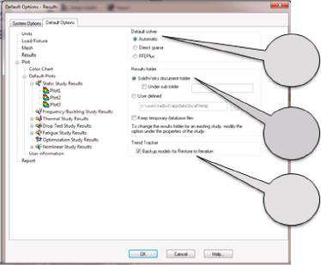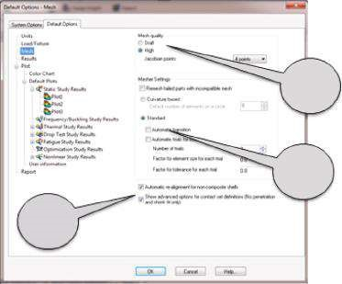

3

a

3

b

3

c

4

a

4

b

4

c

#### Figure 4.2

*Default Options. (a) Units Default Options; (b) Load/Fixture Default Options; (c) Mesh Default Options; (d) Results Default Options.*

results has been discussed in the previous item. Finally, both last options can either be activated or not (3c, Figure 4.2c).

* **Results** (Figure 4.2c) – here the default solver should be chosen (4a, Figure

4.2d). The directory where the results will be saved is directed (4b, Figure 4.2d). It is recommended to select the last button to enable the backing-up of the model for future restoration (4c, Figure 4.2d).

From here on, the **Plot** options (Figure 4.3) will be discussed in detail. These settings are directly related to the visualisation of the obtained results. Of course, the plots are not limited to the default ones, but it is better if the initial plots present the most common results.

* **Plot** (Figure 4.3a) – through that window, **Annotation and range** properties are set (1a, Figure 4.3a). By either checking or not the buttons, the user chooses whether to show the minimal and the maximal values as well as the range of the displayed components. Additionally, some settings’ options regarding the fringe (Point, Line, Discrete and Continues) and the boundary (None, Model, Mesh

(a) (b)

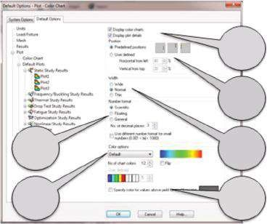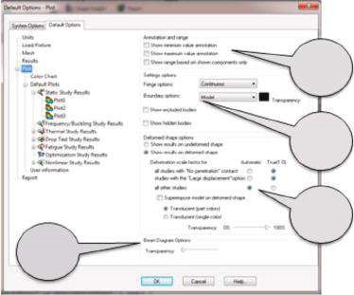

1

a

1

b

1

c

1

d

2

a

2

b

2

c

2

f

2

d

2

e

(c) (d) (e) (f)

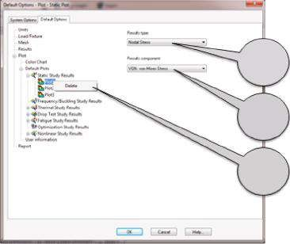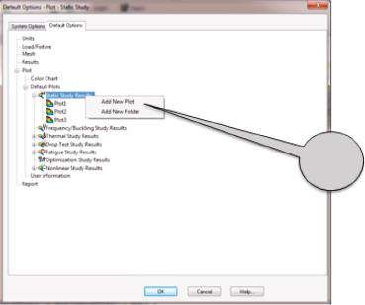

3

4

b

4

c

4

a

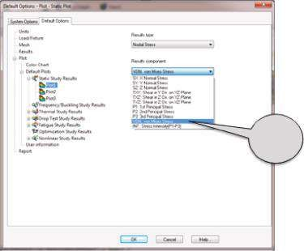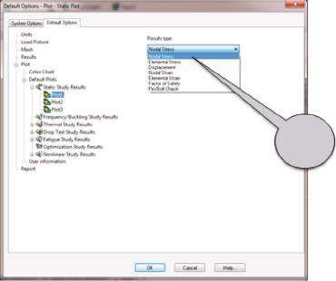

5

6

#### Figure 4.3

*Options of the plots. (a) Plot options; (b) Color Chart options; (c) adding new plots or folders to the results tree; (d) Results tree; (e) Results type; (f) Results component.*

and Translucent) presentations and displaying the hidden and excluded components from the analysis can be defined (1b, Figure 4.3a). The next sub-panel enables the introduction of the deformed shape options (1c, Figure 4.3a), while the last sub-panel is related to the display of the beam diagrams if they exist (1d, Figure 4.3a). For example, for a solid body analysis, as an example provided here, there are no beam parts; hence, there are no such diagrams.

* **Color Chart** (Figure 4.3b) – Through that panel, we can choose to either display or not colour charts and plot details (2a, Figure 4.3b), and to define the position and the width of the chart (2b and 2c, Figure 4.3b). The format of the plot numbers can be Scientific (1.234e+01), Floating (1.234), General, where the number of decimal places is set (if this number is 2, the number is 1.23), or any appropriate, according to the programme for small numbers (2d, Figure 4.3b). The next is the choice of colour palette (2e, Figure 4.3b). It can be **Default** (), **Rainbow** (), **Grayscale** () or **User**

**Defined**. The colour of all areas where **von Mises** stresses are above the yield stresses can also be specified (2f, Figure 4.3b).

* If you right click on a certain type of analysis, **Static Study Results** for example (3a, Figure 4.3c), you can **Add New Plot** to the group of the pre-defined plots related to the folder or **Add New Folder** for a new group of plots. Thus, the **Results** tree can be managed.
* If you right click on a certain plot, you can **Delete** it from the results tree (4a, Figure 4.3d), or if you left click on a certain plot, you can simply change its properties, regarding **Results** type (4b, Figure 4.3d) and **Results** component (4c, Figure 4.3d).
* All possible **Results types** can be seen in Figure 4.3e. The corresponding **Results components** are given in Figure 4.3f. The program automatically relates the components to the chosen type and thus prevents wrong choices. This relation is given in Table 4.1.
* The **User Information** panel (Figure 4.4a) enables the input of some data related to the names of the company and the user and the import of the company logo as an image file of the type *.bmp or *.jpg. This information will be written in the generated report if the last option is selected.
* The final report generation is of high importance for the final presentation of the project results. The program helps us with this uneasy task. The basic sections that should be included in the report can be selected from the **Report** panel (Figure 4.4b). It is crucial at this point to select the right type of analysis from the **Report formats** menu, because the available report formats are customised according to the type of study. Report sections depend on the chosen type of the analysis, and some of them, which are typical for **Static analysis report**, can be seen in the figure (Figure 4.4b). Some user-defined comments and additional data not included in the format (e.g. addition of images of all plots to the **Study Results** section) can be added to each **Report section**. This is free text information, written in the window on the right side of the **Report** panel. All information provided by default for each item of the **Results section** for **Static Study** report is systematised in Table 4.2. Sections included in the final report are not limited to those in the table. An additional user-defined section can be embedded in the **Appendix section**. It can be imported as MS Office data, as a SW image or as any other image file.

***Table 4.1***

#### Relation between Results Type and Results Components

|  |  |  |
| --- | --- | --- |
| **Results Type** |  | **Results Component** |
| Nodal Stress | Nodal stress component | • **SX**: X normal stress |
| Elemental Stress | Elemental stress component | * **SY**: Y normal stress * **SZ**: Z normal stress * **TXY**: shear in Y direction on YZ plane * **TXZ**: shear in Z direction on YZ plane * **TYZ**: shear in Z direction on XZ plane * **P1**: 1st principal stress * **P2**: 2nd principal stress * **P3**: 3rd principal stress * **VON**: von Mises stress * **INT**: stress intensity (P1–P3) * **ERR**: energy norm error * **CP**: contact pressure |
| D isplacement | D isplacement component | * **UX**: displacement (X direction) * **UY**: displacement (Y direction) * **UZ**: displacement (Z direction) * **URES**: resultant displacement * **RFX**: reaction force (X direction) * **RFY**: reaction force (Y direction) * **RFZ**: reaction force (Z direction) * **RFRES**: resultant reaction force * **RX**: rotation (X direction) * **RY**: rotation (Y direction) * **RZ**: rotation (Z direction) * **RMX**: reaction moment (X direction) * **RMY**: reaction moment (Y direction) * **RMZ**: reaction moment (Z direction) * **RMRES**: resultant reaction moment |
| Nodal Strain | Nodal strain component | • **EPSX**: X normal strain |
| Elemental Strain | Elemental strain component   * **SEDENS**: Strain energy density * **ENERGY**: Total strain energy | * **EPSY**: Y normal strain * **EPSZ**: Z normal strain * **GMXY**: shear in Y direction on YZ plane * **GMXZ**: shear in Z direction on YZ plane * **GMYZ**: shear in Z direction on XZ plane * **ESTRN**: equivalent strain * **E1**: normal strain (1st principal direction) * **E2**: normal strain (2nd principal direction) * **E3**: normal strain (3rd principal direction) |
| Factor of Safety Pin/Bolt Check | No result components |  |

The next step is the input of the **Header** information in the **Report** window. It includes Designer, Company, URL and Logo (if any), Address, Phone and Fax. All these data are optional and can be omitted in the final report. With regards to saving the generated file somewhere, the **Report folder** should be set. By default, it is the **Results folder**, although the user can change the directory path.

(a) (b)

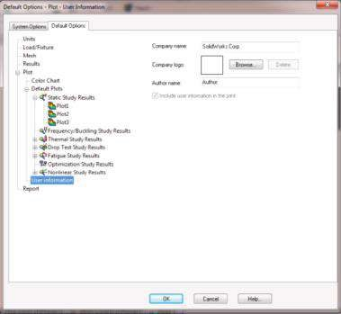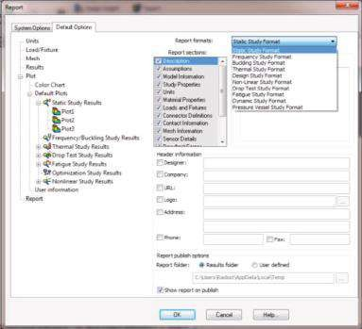

***Figure 4.4***

*(a) User Information and (b) Report panels.*

***Table 4.2***

#### Results Sections for Static Study

**Comments and Report Sections Items Related to Each Report Section by Default Additional Data**

|  |  |  |
| --- | --- | --- |
| D escription |  | User-defined comments |
| Assumptions |  | User-defined comments |
| Model Information | * Names of all referenced components and sub-assemblies * Configuration name used in study * Path to all documents listed * Revision or last modified date * Physical properties of each body * Ply information for composites | User-defined comments |
| Study Properties | * Solution information including study name, analysis type and mesh type * Solver information including solver used in the study * Solver options including properties of the selected study * Result folder | User-defined comments |
| Units | Unit system for   * Length/displacement * Temperature * Angular velocity * Stress/pressure | User-defined comments |

(*continued*)

***Table 4.2* (*Continued*)**

#### Results Sections for Static Study

|  |  |  |
| --- | --- | --- |
| **Report Sections** | **Items Related to Each Report Section by Default** | **Comments and Additional Data** |
| Material Properties | * Material details such as name, yield strength, tensile strength * Values and graph of the material table * D escriptive information for custom-defined materials * Custom material properties defined by the user for the custom-defined materials | User-defined comments |
| Loads and Fixtures | * Fixture names, images, details and resultant forces * Load names, images and details * Values and graphs of the loading for transient analysis | User-defined comments |
| Connector D efinitions | * Types of connectors and details * Connector forces | User-defined comments |
| Contact | • Types of contacts, images and properties | User-defined comments |
| Mesh  Information | * Mesh details and image * Mesh control information (name, image and details) | User-defined comments |
| Sensor Results | • Sensor names, locations and details | User-defined comments |
| Resultant Forces | * Reaction forces * Reaction moments | User-defined comments |
| Beams | Select to include beam stresses or forces at   * Joints * Ends * Extreme values * Entire length | User-defined comments O ptional information:   * Include beam forces * Include beam stresses |
| Study Results | * Includes images of all the plots in the Results folder * Clears or adds manually the desired images using insert image | User-defined comments O ptional information:  • Include images of all plots |
| Conclusion |  | User-defined comments |
| Appendix | Includes an Appendix with external data, either embedded or linked | User-defined comments O ptional information:  • Browse for embedded objects  or links |

All options selected through the **Options** property manager can be saved as they are any time by clicking the **OK** button or can be rejected by clicking **Cancel**. At any time, the **General options** can be set to their default values by clicking the **Reset All** button, displayed at the left bottom of the property manager (Figure 4.1b).

As far as the properties of the visualised results of our study are concerned, we will set the following options starting with opening of the **Options** property manager:

Simulation → Options (Figure 4.1a)

Thus, we open the **General System Options** window (Figure 4.1b). Then we

* Check both **What’s Wrong messages** and **Shaded Load/Fixture symbol quality** – Shaded to be displayed
* Leave **Mesh colors** and **Result plots** options as they are by default and do not change the font properties (Figure 4.1c)
* Check the last two boxes to run the **Simulation Advisor and Command Manager**, hide the excluded components from the analysis and show the study material appearances.

Open the **Default Options** panel and set the options as given below:

* **Units** (Figure 4.2a) – Check **SI** (meter kilogram second) (1a, Figure 4.2a) and input the following units: Length/Displacement – mm; Temperature – Celsius; Angular velocity – rad/s; Pressure/Stress – N/m2 (1b, Figure 4.2a).
* **Load/Fixture** (Figure 4.2b) – Leave the size (2a, Figure 4.2b) and the colour (2b, Figure 4.2b) of the symbols as they are by default. Check the preview option (2c, Figure 4.2b).
* **Mesh** (Figure 4.2c) – Set the quality of the mesh to High and **Jacobian points** to 4 (3a, Figure 4.2c). Choose Standard **Mesher Settings** (3b, Figure 4.2c) but do not check the other two automatic options. If necessary, they could be activated later through the **Mesh** property manager. Finally, you can either check the last two options or not (3c, Figure 4.2c). Their activation is not directly related to the current analysis, considering that the model is a solid body and there are no contact conditions to be defined.
* **Results** (Figure 4.2d) – Check the Automatic **Default solver** (4a, Figure 4.2d). Thus, the program will choose the solver itself comparing the **Direct sparse** to **FFEPlus**. Then we have to input the path to the directory where the data will be kept. We check the **SolidWorks** document folder, and the result files will be kept in the directory where your **SolidWorks** CAD files are located (4b, Figure 4.2d). Then we activate the **Trend Tracker** to keep the previous version in case of failure (4c, Figure 4.2d).
* **Plot** (Figure 4.3) – Leave all checks as they are by default for **Plot** (Figure 4.3a) and **Color Chart** (Figure 4.3b). If necessary, they can later be turned off or be activated for each separate plot. Neither **New Plots** nor **New Folders** will be added (Figure 4.3c). The number of plots for **Static Study** is preserved to be three, as it is by default (4a, Figure 4.3d). For **Plot1**, **Results type** is set to Nodal stress (4b, Figure 4.3d) and **Results component** to VON: von Misesstress (4c, Figure 4.3d). For **Plot2**, these options are Displacement and URES: Resultant Displacement, and for **Plot3**: Element Strain and ESTRN: Equivalent Strain.

(a) (b)

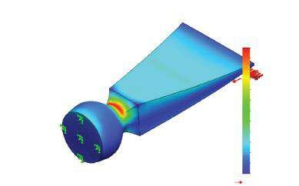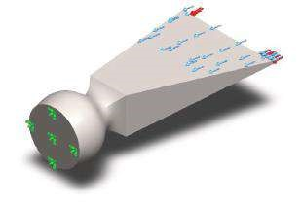

Model name: Chisel1

Study name: Study 1

Plot type: Static nodal stress Stress1

Deformation scale: 24.3562

von Mises (N/m

2

)

539 536 384.0

494 648 192.0

449 759 936.0

404 871 680.0

359 983 424.0

315 095 168.0

270 206 912.0

225 318 656.0

180 430 400.0

135 542 144.0

90 653 904.0

45 765 652.0

877 399.8

Yield strength: 620 422 000.

0

(c) (d)

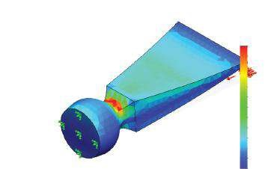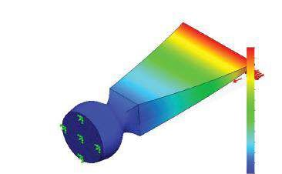

Mo

del name: Chisel1

Study name: Study

1

Plot ty

pe: Static displacement Displacement1

De

formation scale: 24.3562

Model name: Chisel1

Study name: Study 1

Plot type: Static strain Strain1

Deformation scale: 24.3562

1.193e+000

URES (mm)

ESTRN

1.766

e–

003

1.619

e–

003

003

1.472

e–

e–

1.325

003

003

e–

1.178

e–

1.031

003

8.845

004

e–

e–

004

7.376

5.907

e–

004

004

4.438

e–

004

e–

2.969

004

e–

1.500

e–

3.159

006

1.094e+000

9.942

e–

001

8.948

001

e–

7.954

e–

001

001

e–

6.959

5.965

e–

001

4.971

001

e–

3.977

e–

001

e–

001

2.983

e–

1.988

001

9.942

002

e–

030

e–

1.000

##### Fig u r e 4.5

*Some result plots of the static study of the chisel. (a) Chisel solid body model; (b) von Mises stress plot (N/m 2); (c) Displacem ent plot (mm); (d) Elem ent strain equivalent energy.*

* **User Information** (Figure 4.4a) and **Report** (Figure 4.4b) – As this is a study case, there is no need for any specific data to be introduced here. Leave all options as they are by default.
* Click **OK** to keep all changes and to close the **Options** property manager.

The results of the analysis performed in Chapters 2 and 3, according to the above set options, are given in Figure 4.5.

We studied what and how result properties can be set before running the analysis. These properties affect the visualisation of the entire results data, yet they can be modified later if necessary.

|  |
| --- |
| We learned how to   * D efine default General system options * D efine default analysis options, including units, loads and restraints, mesh settings and the default solver * Set the default properties and types of plots * View plots * Generate automatically the final report * Add user-defined information in the report * Set the directories, where all result files and the report will be saved |

### 4.2 DIFFERENT WAYS TO SYSTEMATISE AND PLOT THE RESULTS OF FEA

After running the study and reaching the post-processor stage, all results that are kept in the computer memory can be systematised and viewed. The program enables a few ways to present the results and thus to make their analysis easier. These ways are as follows:

* **Plotting the results** – probably the most commonly used way, especially in the early stages of the analysis. It makes it easier to get a general overview of the type of plotted results.
* **Listing the results** – enables numerical presentation of the results. It consists of enormous quantity of numbers, and sometimes, it is difficult to get the entire picture; yet this type of result presentation is preferred when a higher level of accuracy is needed.
* **Drawing graphs** – helps to see how a certain result type changes versus one parameter (for example, versus a geometrical position or time). It is a reasonably good way to combine visual and numerical data, especially throughout vulnerable zones.
* **Generating reports** – this is a very useful way of presenting the entire analysis data. The embedded structure of the automatically generated reports guides successfully the beginners throughout the presentation of their study.

All commands related to the presentation and systematisation of the results can be activated through either of the following:

* **Simulation Advisor** (, 1c, Figure 4.6c), which can be started through the **SW Simulation command** **bar –** **Study Advisor** (, 1a, Figure 4.6a)
* **Results Advisor** (, 1b, Figure 4.6b) and the corresponding pop-up menu
* **SW Simulation analysis tree** by right clicking on the **Results** folder (2a, Figure 4.6c) and picking any command of the pop-up menu (2b, Figure 4.6c).

The **Simulation Advisor/Results** guides the user through the display of the results (Figure 4.6d). As this is the easiest way of systematising the results, we will start our discussion about the display of the FEA results with it.

#### 4.2.1 Results Display through Simulation Advisor

Probably this is the easiest way to systematise the results, because the user is guided step by step by the **Simulation Advisor**. If you answer correctly and cleverly to all questions that the **Simulation Advisor** () asks, you will have a reasonably good analysis of the final results in the end. This way of viewing the results is recommended for beginners.

There are three ways to activate the **Simulation Advisor**:

• Through the **SW Simulation** **command bar** by clicking the **Study Advisor** icon (, 1a, Figure 4.6a), and after that, selecting the **Results Advisor** from the **Simulation Advisor** panel (3a, Figure 4.6d), which opens on the right side of the **Graphics area**

(a) (d)

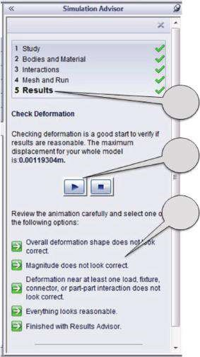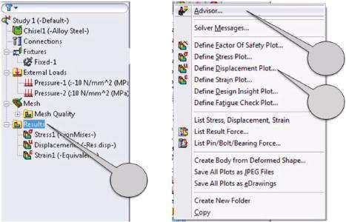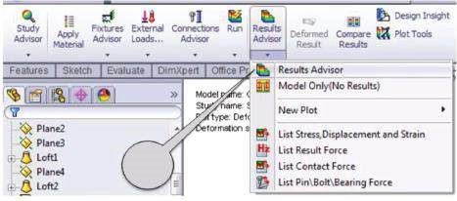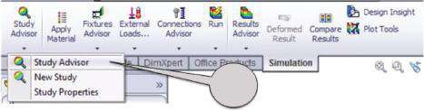

(

b

)

(

c

)

1

b

2

a

1

c

2

b

1

a

3

a

3

b

3

c

##### Figure 4.6

*Activating Simulation Advisor – Results. (a) Through SW Simulation command bar – Study Advisor; (b) through SW Simulation command bar – Results Advisor; (c) through SW Simulation analysis tree – Results folder; (d) Simulation Advisor – Results Advisor.*

* Through the **SW Simulation** **command bar** by clicking the **Results Advisor** icon (, 1b, Figure 4.6b), which directly opens the **Results Advisor** window of the **Simulation Advisor** (Figure 4.6d)
* Through the **SW Simulation** **analysis tree** by right clicking the **Results** folder (2a, Figure 4.6b) and then clicking on the **Advisor** icon at the newly opened pop-up menu (, 1c, Figure 4.6b)

The next step is to follow strictly the recommendations of the **Simulation Advisor**

(). The systematisation of the results starts with

* **Checking the deformations** – By clicking the play button (3b, Figure 4.6d), the program generates a video clip to present the process of deformation of the body (Figure 4.7). Additionally, the value of the maximum displacement

Model name: Chisel1

Study name: Study 1

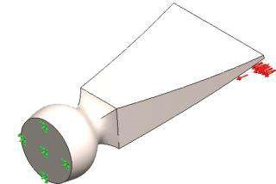Plot type: Deformed shape displacement1{1}

Deformation scale: 24.3562

##### Fig u r e 4.7

*Deformed shape of the chisel.*

is given. In our case, it is 0.00119 m (see Figure 4.6d). After that, based on your experience, you have to assess the result in one of the following possible ways (3c, Figure 4.6d):

* Overall deformation shape does not look correct.
* Magnitude does not look correct.
* Deformation near at least one load, fixture, connector or part–part interaction does not look correct.
* Everything looks reasonable.
* Finished with Results Advisor.

Depending on your response, the program suggests some reasons for not achieving the correct deformed form or starts the next step.

* If **the generated deformed shape is wrong** (Figure 4.8a), the most common reasons according to the program are wrong load direction and amplitude. Possible suggestions for improvement include review of the loads and fixtures, re-examination of your expectations and, after finding the problem and correcting it, re-running the analysis.
* If **the magnitude of the generated deformed shape seems wrong**

(Figure 4.8b), possible reasons could be as follows: the scale of the animation is not correct; the load is applied to each separate entity instead of the total; the model is under- or over-restrained; the material properties are not correct; the real deformations are nonlinear, and stress stiffening or softening occurs; and the load magnitude or its direction is wrong. It is very difficult to judge whether the model or your expectations are wrong. Hence, it is better to check the model carefully and, if everything seems correct, to re-examine your expectations.

* If **the displacements near loads, fixtures, connectors or contacts seem wrong** (Figure 4.8c), the most common reasons could be wrong type or settings of the fixtures, that is, the fixture restricts or allows movement that the physical model does not perform; load causes unexpected deformations; and parts are bonded when they should move relatively or just the opposite. The program’s suggested possible ways to eliminate the problem include revision of the applied fixtures and loads or revision of the user’s expectations.
* If **the stiffness of the model does not seem correct** (Figure 4.8d), the program suggests to use a stiffer material; if bending is a problem, to increase

(a) (b)

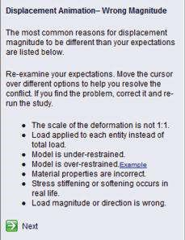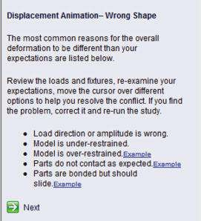

(c) (d)

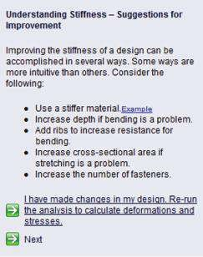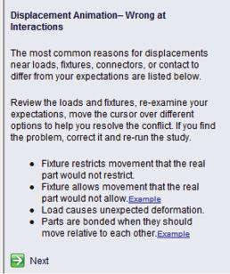

##### Figure 4.8

*Possible causes of the observed displacement results. (a) Wrong Shape; (b) Wrong Magnitude; (c) Wrong at Interactions; (d) Understanding Stiffness.*

depth or to add ribs to increase resistance to bending; and if stretching is a problem, to increase cross-sectional area or simply to increase the number of fasteners.

All these data are systematised in Table 4.3.

If the deformation movie and all corresponding data seem correct, by clicking the option **Everything looks reasonable**, the next step of viewing the results is activated (3c, Figure 4.6d).

This is the **Other Result Concerns** window (Figure 4.9), as different result types address different concerns, and the final goal is obtaining satisfying and accurate results. This window enables the consideration of some other possible reasons for not obtaining precise results (Table 4.4). Other options that can be selected are as follows (Figure 4.9a): Material breaking or yielding, Failure under repeated loading and unloading, Other failure modes or Finished with Results Advisor.

Regarding our choice, the result view continues with the following:

• If the selected option is **Material breaking or yielding**, plotting of the following results is enabled (Figure 4.9b):

***Table 4.3***

#### Possible Causes of the Observed Displacement Results

**Possible Options after**

|  |  |  |
| --- | --- | --- |
| **the Review of the Animation** | **Possible Reasons for the Observed Results** | **Possible Ways to Eliminate the Problem** |
| O verall deformation shape does not look correct | • Wrong shape | * Load direction or amplitude is wrong. * Model is under-restrained. * Model is over-restrained. * Parts do not contact as expected. * Parts are bonded but should slide. |
|  | • Wrong magnitude | * The scale of the deformation is not 1:1. * Load applied to each entity instead of total load. * Model is under-restrained. * Model is over-restrained. * Material properties are incorrect. * Stress stiffening or softening occurs in real life. * Load magnitude or direction is wrong. |
|  | • Wrong at interactions | * Fixture restricts movement that the real part would not restrict. * Fixture allows movement that the real part would not allow. * Load causes unexpected deformation. * Parts are bonded when they should move relative to each other. |
|  | • Understanding stiffness | * Use a stiffer material. * Increase depth if bending is a problem. * Add ribs to increase resistance for bending. * Increase cross-sectional area if stretching is a problem. * Increase the number of fasteners. |
| Magnitude does not look correct | • Wrong magnitude | * The scale of the deformation is not 1:1. * Load applied to each entity instead of total load. * Model is under-restrained. * Model is over-restrained. * Material properties are incorrect. * Stress stiffening or softening occurs in real life. * Load magnitude or direction is wrong. |

(*continued*)

***Table 4.3* (*Continued*)**

#### Possible Causes of the Observed Displacement Results

|  |  |  |
| --- | --- | --- |
| **Possible Options after the Review of the Animation** | **Possible Reasons for the Observed Results** | **Possible Ways to Eliminate the Problem** |
| Magnitude does not look correct | • Wrong at interactions | * Fixture restricts movement that the real part would not restrict. * Fixture allows movement that the real part would not allow. * Load causes unexpected deformation. * Parts are bonded when they should move relative to each other. |
|  | • Understanding stiffness | * Use a stiffer material. * Increase depth if bending is a problem. * Add ribs to increase resistance for bending. * Increase cross-sectional area if stretching is a problem. * Increase the number of fasteners. |
| D eformation near at least one load, fixture, connector or part–part interaction does not look correct | • Wrong at interactions | * Fixture restricts movement that the real part would not restrict. * Fixture allows movement that the real part would not allow. * Load causes unexpected deformation. * Parts are bonded when they should move relative to each other. |
|  | • Understanding stiffness | * Use a stiffer material. * Increase depth if bending is a problem. * Add ribs to increase resistance for bending. * Increase cross-sectional area if stretching is a problem. * Increase the number of fasteners. |
| Everything looks reasonable | • Next |  |
| Finished with Results Advisor | • Final |  |

• The first plot is that of **Factor of Safety (FoS)**. It assesses the safety of the design based on the maximal stresses, the material properties and the failure criteria. Values in the range (0, 1) indicate failure and outline vulnerable zones. In our case, FoSmin = 1.15 (Figure 4.10a). There are some techniques that can help to increase FoSmin. They either improve the strength or reduce the stress. You can think about considering an alternative material, adding or increasing fillet radii, adding ribs or gussets or increasing the number of fasteners. All techniques except the first concern the construction of the real part. By default, material change means higher modulus of elasticity to increase the stiffness. Usually, the relation is proportional,

(a) (b) (c) (d)

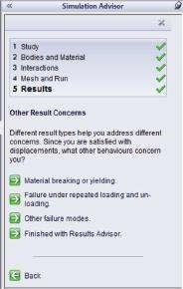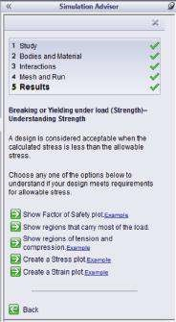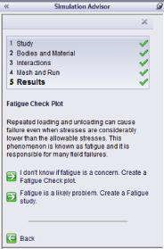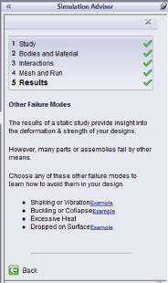

##### Fig u r e 4.9

*Other results concerns. (a) Other Result Concerns panel; (b) Understanding Strength; (c) Fatigue Check; (d) Other Failure Modes.*

***Table 4.4***

#### Other Possible Causes of the Observed Displacement Results

|  |  |  |
| --- | --- | --- |
| **Possible Options after**  **Assessment of the Animation** | **Possible Reasons for the Observed Results** | **Possible Next Choices** |
| Material breaking or yielding | • Breaking or yielding under load  (strength) –  Understanding strength | * Show Factor of Safety plot * Show regions that carry most of the load * Show regions of tension and compression * Create a Stress plot * Create a Strain plot |
| Failure under related loading and unloading | • Fatigue Check Plot | * I don’t know if fatigue is a concern. Create a Fatigue Check plot * Fatigue is likely a problem. Create a fatigue study |
| O ther failure modes | • O ther Failure  Modes | * Shaking or Vibration * Buckling or Collapse * Excessive Heat * D ropped on Surface |
| Finished with Results Advisor | • Final |  |

and the higher the modulus, the less the deflection. Another very important question is whether the results are accurate. You must remember that sometimes the displacements can seem accurate enough, while the stresses can bother you. The reason is the workflow of the used calculation techniques; that is, first, the displacements are calculated and, after that as a chain, based on strain relations and Hook’s law, the stresses. A very simple way to overcome that uncertainty about the stress results is to

(a) (b)

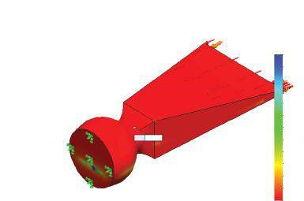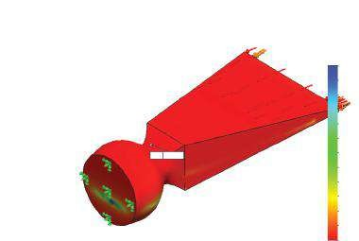

Mo

del name: Chisel1

Study name: Study

1

Plot ty

pe: Factor of Safety Factor of Safety1

Criterion:

Automatic

Fa

ctor of safety distribution: Min FOS = 1.1

Model name: Chisel1

Study name: Study 1

Plot type: Factor of Safety Factor of Safety1

Criterion: Automatic

Factor of safety distribution: Min FOS = 1.1

Min: 1.15

Min: 1.12

FOS

FOS

1 015.77

762.11

677.56

593.00

508.45

423.89

339.34

254.78

170.23

85.68

1.12

931.22

846.66

707.11

648.28

589.45

530.62

471.79

412.96

354.13

295.30

236.47

177.64

118.81

59.98

1.15

##### Fig u r e 4.10

*FoS plots. (a) Using none-adaptive method; (b) using h-adaptive method.*

generate a finer mesh and to re-run the study. If the results do not change significantly, everything is OK. Otherwise, you can use automatic adaptive methods or enable the h-adaptive method and re-run the study. In our case, just to compare the FoS results for non-adaptive and h-adaptive methods, the analysis is re-run and the result is that the h-adaptive method has satisfied the current accuracy of 98.3133%. There is no need to increase the target accuracy FoSmin = 1.12. Thus, FOSnone-adaptive methodmin >FOSh-adaptivemin method.

* The next step is to **Show regions that carry most of the load**. Thus, the **Design Inside** plot is started. It shows the volumes that work the hardest (Figure 4.11) and helps us to improve FoS levels. For example, if FoS is too low, additional material could be added in the vulnerable zones, or if FoS is unreasonably high, the body weight can be reduced by removing some material. This plot guides us through these constructional improvements by showing different load levels all over the body. As a result, the body will have better construction and lower weight, and probably its final cost would be reduced as well.
* The next plot is **Shows regions of tension and compression**. It plots areas with tensile stresses versus compressed areas. There are two really large groups of materials. The first group includes the **ductile materials**,

(a) (b)

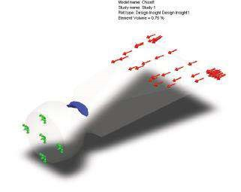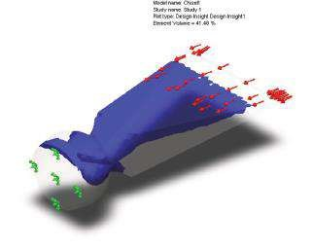

Mo

del name: Chisel1

Study name: Study

1

Plot ty

pe: Design Insight Design Insight1

Element

Volume = 0.76%

Model name: Chisel1

Study name: Study 1

Plot type: Design Insight Design Insight1

Element Volume = 41.48%

##### Fig u r e 4.11

*Plots of the regions that carry most of the loads. (a) Regions that are loaded more than 90%; (b) regions that are loaded more than 30%.*

which carry well-enough tension and compression. Almost all alloys, steel, iron and many other materials belong to this group. The second group combines the **brittle materials**, such as concrete, cast iron, etc. They work very well when exposed to compression, but unfortunately, their reliability, when exposed to tension, is questionable. That is why no matter to which group the material of the body belongs, tensile stress is more of a concern than the compressive one, especially when yielding or fracture is a concern. Additionally, when the body is bended, based on our experience, it is reasonable for tensile stresses to be spread on one side of the body (the side that is opposite of the entity at which the load is applied) and the compressive stresses on the other (Figure 4.12).

* **Stress plot** presents the distribution of different stresses over the body contour or inside. In our case, the von Mises stress plot is given (Figure 4.13a). Its maximum is about 540 MPa in an area at the gudgeon of the chisel. The yield stress for the selected material is 620 MPa. Therefore, there is no need for any constructive changes regarding the appearance of the chisel to be made.
* The last proposed by the **Results Advisor** plot is the **Strain plot**. It is used to gain an idea of the inside of the body strain. This plot is useful if there are any on-site strain measurements. The existing relation between

(a) (b)

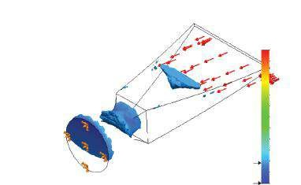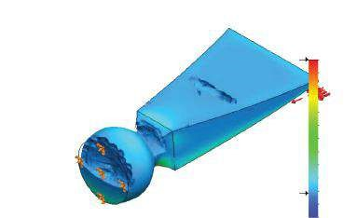

Mo

del name: Chisel1

Study name: Study

1

Plot ty

pe: Static nodal stress Stress2

De

formation scale: 24.3562

Model name: Chisel1

Study name: Study 1

Plot type: Static nodal stress Stress2

Deformation scale: 24.3562

P1 (N/m

2

)

P1 (N/m

2

)

353 521 536.0

318 762 688.0

284 003 872.0

249 245 056.0

214 486 208.0

179 727 376.0

144 968 544.0

110 209 712.0

75 450 880.0

40 692 048.0

5 933 216.0

–28 825 616.0

–63 584 448.0

353 521 536.0

318 762 688.

0

284 003 872.

0

249 245 056.

0

214 486 208.0

179 727 376.0

144 968 544.0

110 209 712.

0

75 450 880.0

40 692 048.0

5 933 216.0

–28 825 616.

0

–63 584 448.0

##### Fig u r e 4.12

*Plots of regions of tension and compression. (a) Regions of tension; (b) regions of compression.*

(a) (b)

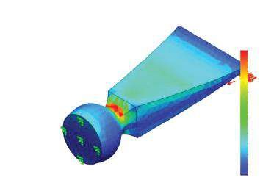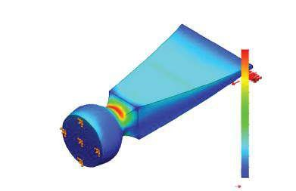

Mo

del name: Chisel1

Study name: Study

1

Plot ty

pe: Static nodal stress Stress3

De

formation scale: 24.3562

Model name: Chisel1

Study name: Study 1

Plot type: Static strain Strain2

Deformation scale: 24.3562

von Mises (N/m

2

)

ESTRN

539 536 384.0

494 648 192.0

449 759 938.0

404 871 680.0

359 983 424.0

315 095 168.0

270 206 912.0

225 318 656.0

180 430 400.0

135 542 144.0

90 653 904.0

45 765 652.0

877 399.8

Yield strength: 620 422 000.0

1.766

e–

003

1.619

003

e–

003

e–

1.472

003

e–

1.325

e–

003

1.178

1.031

e–

003

8.845

e–

004

7.376

e–

004

5.907

e–

004

4.438

e–

004

2.969

004

e–

1.500

e–

004

3.159

e–

006

##### Fig u r e 4.13

*Plots of stress and strain. (a) von Mises plot; (b) Equivalent strain plot.*

strain and stresses helps for easier assessment and comparison of the accuracy of these plots. The **Equivalent strain** plot is shown in Figure 4.13b. The maximal values are at the same area as the maximal von Mises stresses.

* The next possible option deals with **fatigue phenomenon** (Figure 4.9c). This is a process during which stresses less than the allowable can cause failure due to their constant variation, particularly by repeated loading and unloading of the body. This phenomenon is known as fatigue, and it is the reason for many unpredicted field failures, especially in structures made of brittle materials like cast iron. There are two possible answers to the question regarding fatigue. The first is to create a **Fatigue Check** plot if we are not aware of the influence of the fatigue. The second choice is to assume that fatigue might be a problem and to develop **Fatigue study** ().
* The last option has to do with **Other Failure Modes** (Figure 4.9d). Usually this option is not directly related to **Static study** and suggests possible reasons for failure. They can be observed during dynamic loading such as Shaking and Vibration; can be due to buckling phenomenon such as Buckling or Collapse; can be related to thermal effects such as Excessive Heat; or finally can be a consequence of dropping of the body such as Dropped on Surface.

In conclusion, it must be admitted that viewing the results through the **Results Advisor** strongly limits their presentation. As you have probably noticed, only certain plots have been shown, and there are no accompanying lists or graphs. That is why the other two ways of viewing the results are more commonly used.

We learned that viewing the results can be done in different ways and one of them uses the **Results Advisor** (Figure 4.6d).

It starts with a **Check of the deformations** (Figure 4.7), where in order to continue, we are expected to select one of the suggested answers. It is possible for

* The generated **deformed shape to be wrong** (Figure 4.8a)
* The **magnitude of the generated deformed shape to seem wrong**

(Figure 4.8b)

* The **displacements near loads, fixtures, connectors or contacts to seem wrong** (Figure 4.8c)
* The **stiffness of the model not to seem correct** (Figure 4.8d)

There are different ways to eliminate the problems, if there are any. The most common of them are prompted by the **Results Advisor**; others depend on our knowledge and experience.

If clicking **Everything looks reasonable**, the next level of viewing the results is reached. At this point, some **Other Result Concerns** (Figure 4.9a) occur. They can be

* **Material breaking or yielding** (Figure 4.9b). To assess the results correctly, some plots can be generated. They are the **FoS** plot (Figure 4.10); the **Show regions that carry most of the load** or **Design Inside** plot (Figure 4.11); the **Show regions of tension and compression** plot (Figure 4.12); and the **Stress** plot (Figure 4.13a) and **Strain** plot (Figure 4.13b).
* **Fatigue phenomenon** (Figure 4.9c), where there are two available options: to create a **Fatigue Check** plot or to develop **Fatigue study**.
* **Other Failure Modes** (Figure 4.9d), including Shaking and Vibration; Buckling or Collapse; and Excessive Heat or Dropped on Surface.

Finally, we click the **Finished with Results Advisor** to close the **Simulation Advisor** (Figure 4.6d).

|  |
| --- |
| D uring this chapter, guided by the Results Advisor, we learned how to   * Generate deformed shape clips and plots * Check for possible reasons for incorrect deformations and consider the most common ways to eliminate the problem * Consider some O ther Result Concerns, related to stress and strain distribution * Make some changes in the design to improve the final results |

##### 4.2.2 Results Display through Results Folder in the Analysis Tree

Another way to display the results is through the **Results** folder in the analysis tree (Figure 4.6c). You can start viewing the results by either showing the plots that are at the analysis tree (Figure 4.14a), and which number and properties are defined by default (see Section 4.1), or by creating new plots, listings and drawings using the **Results** pop-up menu (Figure 4.14b), which can be opened by right clicking on the **Results** in the **SW Simulation** **analysis tree.**

This time, the view of the results will start with the default plots (Figure 4.14a). If we right click on the plot that is not highlighted/active, a small pop-up **Property** menu opens (Figure 4.15a). It includes only a few of the commands that are accessible in the larger **Property** menu, which opens after right clicking on an active plot (Figure 4.15b).

(a) (b)

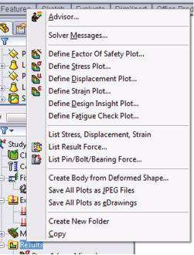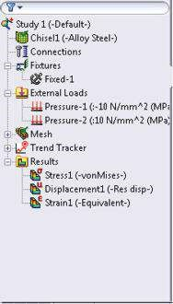

###### Fig u r e 4.14

*Display of the results through the Results folder in the analysis tree. (a) Analysis tree with default plots; (b) Results pop-up menu.*

(a) (b)

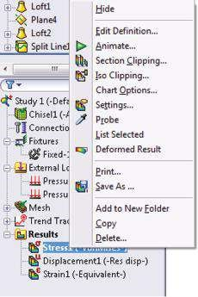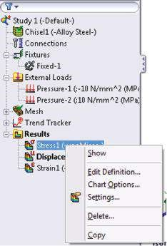

###### Fig u r e 4.15

*Property menus of plots. (a) Pop-up Property menu of a non-active plot; (b) pop-up Property menu of an active plot.*

Each plot can be selected either by double left clicking on its name in the **SW Simulation** **analysis tree** or by selecting the **Show** command in the pop-up **Property** menu (Figure 4.15a). After selecting the plot, it is automatically displayed in the **Graphics area**. Its features coincide with the plot’s pre-defined properties.

All these properties can be changed through the pop-up **Property** menu (Figure

4.15b). The commands from that menu are discussed in detail below:

* The **first** command is an alternative **Show/Hide** command. It either activates or deactivates the current plot.

The **second group** combines commands through which the user can directly influence the properties of the plot visualisation.

* **Edit Definition** – This command is available in the two **Property** menus (Figure 4.15). At first, we will explain how this command works when it is associated with the **Stress** plot, and after that, we will compare it to the corresponding **Edit Definitions**, related to **Displacement** and **Strain** plots. Clicking on **Edit Definition** opens the window shown in Figure 4.16a. All options related to that command are grouped in **Display** (1b, Figure 4.16a), **Advanced Options** (1c, Figure 4.16a), **Deformed Shape** (1d, Figure 4.16a) and **Property** (1e, Figure 4.16a) sub-windows. It is important to remember the operation of the **OK** (), **Cancel** () and **Pin** () functions (1a, Figure 4.16a).
* Through the **Display** sub-window, you have to choose the **Component** (, Figure 4.16b) to be displayed and the corresponding **Units** (, Figure 4.16c). There are 13 stress components accessible for solid body models and you have to select one of them. These components are combined in a few groups: **Normal stresses – SX**: X normal stress; **SY**: Y normal stress; **SZ**: Z normal stress (2a, Figure 4.16b); **Shear/Tangential stresses – TXY**: shear in Y direction on the YZ plane; **TXZ**: shear in Z direction on the YZ plane; **TYZ**: shear in Z direction on the XZ plane (2b, Figure 4.16b);

(a) (b) (c)

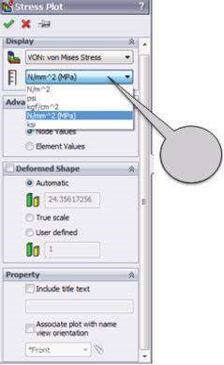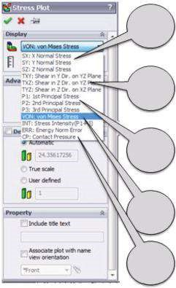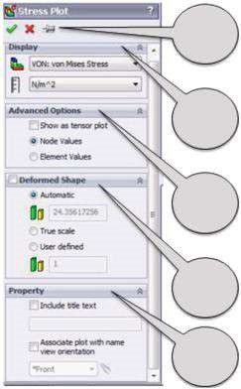

1

a

1

b

1

c

1

d

1

e

2

a

2

b

2

c

2

d

2

e

3

(d) (e) (f)

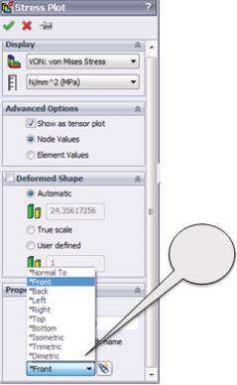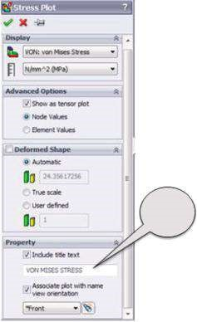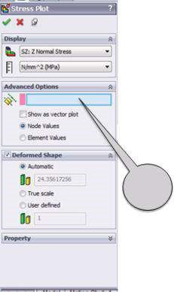

4

5

6

###### Fig u r e 4.16

*Edit Definition property manager of Stress plot. (a) Edit Definition for Stress plot; (b) Display m enu; (c) units of the selected param eter; (d) input of reference entity (optional); (e) input of title; (f) associate plot with name view orientation.*

**Principal stresses** **–** **P1**: 1st principal stress; **P2**: 2nd principal stress; **P3**: 3rd principle stress (2c, Figure 4.16b) and **von Mises Stress** (2d, Figure 4.16b)*,* **Stress Intensity** (P1–P3), **ERR**: Energy Norm Error, **CP**: Contact Pressure (2e, Figure 4.16b). Directions of the stresses are based on the selected reference geometry or on the original orthogonal coordinate system, which is set by default. Here, I would like to remind you that the stress state in one point of the solid body can be completely defined by 18 different stresses – 3 at each side of the stress cube (Figure 4.17a) but only 6 of them are independent. Thus, to describe the stress state in a point, it is enough to know the values of the 6 independent stresses,

(

a

)

(

b

)

T X Y

T YX

T Z Y

T X Z

T YZ

TZX

SZ

SY

P1

P3

P2

SX

*x*

*x*

*V*

*V*

*y*

*z*

*z*

*y*

###### Fig u r e 4.17

*Stress cube. (a) Stress cube with basic stresses; (b) stress cube with principal stresses.*

which include 3 normal (SX, SY, SZ) and 3 shear stresses (TXY, TXZ, TYZ). If the stress cube rotates about the point, the values of the stresses change. It is always possible to orientate the cube in such a way that there will be no shear stresses in its sides. Then the normal stresses will coincide with the principle stresses (P1, P2, P3, Figure 4.17b). Plots of **First Principal Stress** (P1, σ1) and of **Tangential Stress** (TYZ, τYZ) are shown in Figure 4.18a and b. The next two plots show dependency of the plotted component on the reference geometry. The plot of **Normal Stress** SZ (SZ, σZ, Figure 4.18c) uses the initial coordinate system, whereas the plot in Figure 4.18d uses a newly defined coordinate system, in which the Z axis is parallel to the X axis of the initial system. Thus, the stress distribution in this plot coincides with the SX plot using the initial coordinate system.

• The second sub-window of the **Edit Definition** property manager combines **Advanced Options** (Figure 4.16d). The first option is the **Reference geometry** (, 4, Figure 4.16d). The reference plane, axis or coordinate system can be selected through clicking on the signature in the floating **Design tree** in the **Graphics area** or by directly clicking on the entity. The signature of the selected entity is automatically displayed in the blue window. This option is accessible only for directional stresses, such as normal or shear stresses. In spite of its availability, the input of reference entity is not mandatory, and the program uses the original coordinate system by default. The second option controls the visualisation of the stresses: chart plot (Figure 4.18e), vector or tensor plot (Figure 4.17f). The tensor plot of von Mises stresses is shown. The vector mode plots the stresses at each node in relation to their magnitude and direction. After that, either a node mode or an element mode must be selected. The node mode (**Node Values**, Figure 4.16d) generates plots based on the calculated stress component values in the nodes and inner interpolation among them. As a rule, the plot is smooth and good-looking (Figure 4.18). The element mode (**Element Values**, Figure 4.16d) generates plots based on the calculated stress components at the centres of the elements – one value/colour for each element. This mode is considered a criterion about the quality of the mesh. If the plot is rough and the difference in colours of two neighbouring

(a) (b)

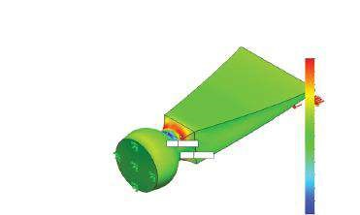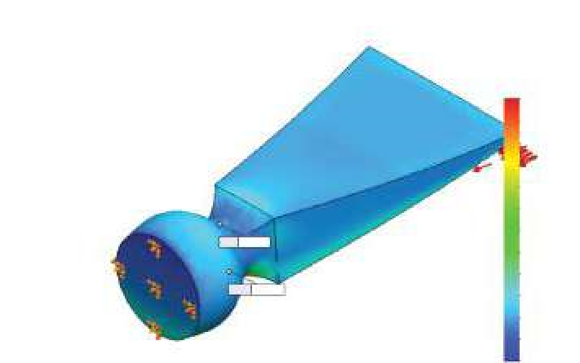

Mo

del name: Chisel1

Study name: Study

1

Plot ty

pe: Static nodal stress Stress1

De

formation scale: 24.3562

Model name: Chisel1

Study name: Study 1

Plot type: Static nodal stress Stress1

Deformation scale: 24.3562

Min: –63.6

Min: –156.3

Max: 104.8

Max: 353.5

P1 (N/mm

2

(MPa))

TauYZ (N/mm

2

(MPa))

104.8

83.0

61.3

39.5

17.8

–4.0

–25.8

–47.5

–69.3

–91.1

–112.8

–134.6

–156.3

353.5

318.8

284.0

249.2

214.5

179.7

145.0

110.2

75.5

40.7

5.9

–28.8

–63.6

(c) (d)

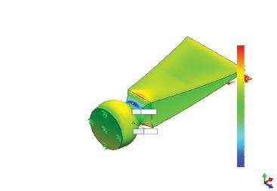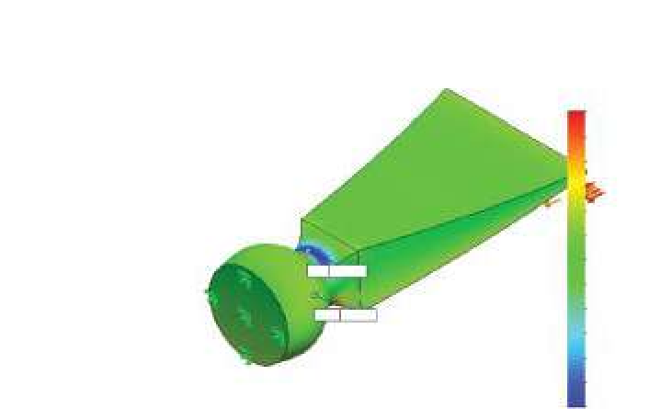

Mo

del name: Chisel1

Study name: Study

1

Plot ty

pe: Static nodal stress Stress1

De

formation scale: 24.3562

Model name: Chisel1

Study name: Study 1

Plot type: Static nodal stress Stress1

Reference geometry: Right Plane

Deformation scale: 24.3562

Max: 346.2

Min: –585.5

Min: –120.6

Max: 66.6

SZ (N/mm

2

(MPa))

SZ (N/mm

2

(MPa))

66.6

51.0

35.4

19.8

4.2

–42.6

–89.4

–105.0

–120.6

Y

X

Z

–58.2

–73.8

–11.4

–27.0

346.2

268.6

190.9

113.3

35.6

–42.0

–119.7

–197.3

–275.0

–352.6

–430.2

–507.9

–585.5

(e) (f)

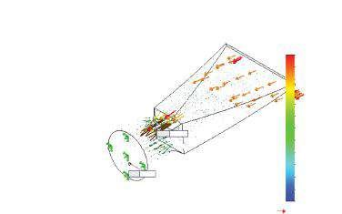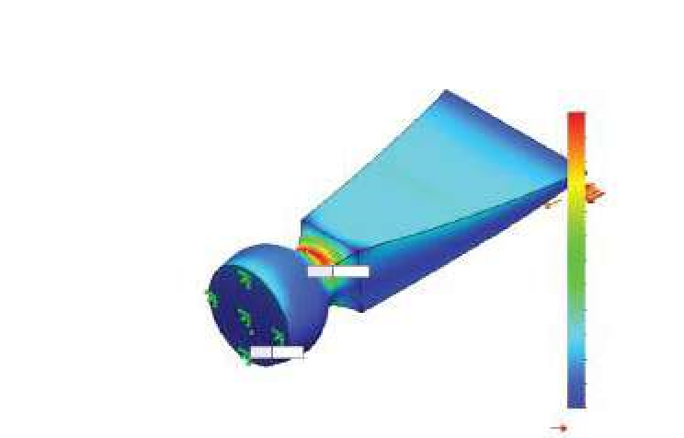

Mo

del name: Chisel1

Study name: Study

1

Plot ty

pe: Static nodal stress Stress1

De

formation scale: 24.3562

Model name: Chisel1

Study name: Study 1

Plot type: Static nodal stress Stress1

Deformation scale: 24.3562

Max: 539.5

Max: 539.5

Min: 0.9

Min: 0.9

von Mises (N/mm

2

(MPa))

539.5

494.6

449.8

404.9

360.0

315.1

270.2

225.3

180.4

135.5

90.7

45.8

0.9

Yield strength: 620.4

von Mises (N/mm

2

(MPa))

539.5

494.6

449.8

404.9

360.0

315.1

270.2

225.3

180.4

135.5

90.7

45.8

0.9

Yield strength: 620.4

###### Fig u r e 4.18

*Different Stress plots. (a) Plot of First Principal Stress (P1, σ1); (b) plot of Tangential Stress (TYZ, τYZ); (c) plot of Norm al Stress SZ (SZ, σZ); (d) plot of Normal Stress SZ with a reference plane (SZ, σZ); (e) plot of von Mises Stress (VON, σred); (f) Tensor plot of von Mises Stress (VON, σred).*

elements seems unreasonably contrasting, then the mesh is too coarse and the model should be re-meshed with a finer mesh and re-run. If the plot is smooth and good-looking, the quality of the mesh is OK.

* The next displayed sub-window defines the properties of the deformed shape. The existing possible options are as follows: **Automatic** – **Scale Factor** () is automatically calculated in a way that the program scales the largest deformation to 10% of the largest dimension of the smallest box that surrounds the model; **True scale** – Scale Factor = 1; **User defined** – the user inputs the scale factor.
* The last sub-window is titled **Properties** (Figure 4.16e and f). It enables the input of a title text to the plot and the association of the current view with the active plot – **Associate with current view** (), regarding or not the **Zoom to fit** function.
* **Animate** (, Figure 4.15b) – This command is available only in the pop-up **Property manager** of an active plot. For a static study, this option creates a video clip (*.avi), which simulates the deformation of the body as a process. There are two sub-windows: **Basics** (1a, Figure 4.19) and **Save as AVI file** (1b, Figure 4.19).
* The available **Basics** icons correspond to the common, well-known labels: **Play** (); **Pause** (); **Stop** (); **Frames** ( ), which sets the number of frames to be used in an animation; **Speed** ( ), which controls the speed of the animation; **Forward Only** ( ), which plays the animation forward one time; **Loop** (), which plays the animation in a continuous looping pattern; and **Reciprocate** (), which plays the animation from start to end, then end to start, and continues repeating.



The following are accessible through the second sub-panel commands: **Option**, which sets the compressor to be used, and **Browse** and optional **View with Media Player**.

* **Section Clipping** (, Figure 4.15b) – This command is available only in the pop-up menu of an active plot, just like the **Animation** command. It enables plotting different section views of the displayed result. It combines two or more sub-windows, each corresponding to a different section (Figure 4.20).
* The first sub-window is titled **Section 1** (1, Figure 4.20a). By selecting one of the icons **Plane** (), **Cylinder** () or **Sphere** () (1a, Figure 4.20a), and pointing an appropriate reference entity directly in the **Graphics area** (1b, Figure 4.20a), different types of sections can be generated. By clicking the button **Reverse clipping direction** (), which is at the left of the window, the direction of the cut can be flipped. Through the **Distance**

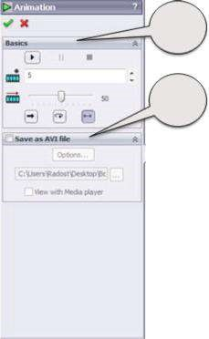

1

a

1

b

###### Fig u r e 4.19

*Anim ation property m anager.*

(a) (b) (c)

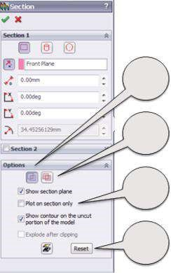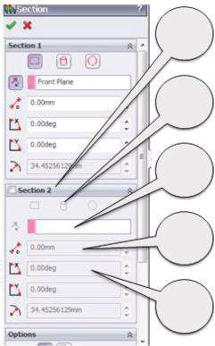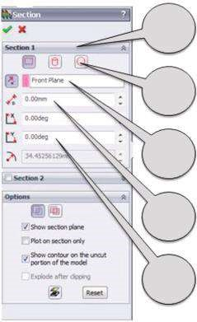

1

1

a

1

b

1

c

1

d

2

2

a

2

b

2

c

2

d

3

3

a

3

b

3

c

###### Figure 4.20

*Section property manager. (a) Section 1 sub-window; (b) Section 2 sub-window; (c) Options sub-window.*

icon (), the offset distance measured from the selected entity can be set (1c, Figure 4.20a). It uses the default units. By introducing some values in the next two windows – **Rotation X** () and **Rotation Y** () (1d, Figure 4.20a) – the section can be rotated around the **X** or **Y** axis. The last window – **Radius** () – is highlighted only when cylindrical or spherical sections are selected.

* The next sub-window is titled **Section 2** (2, Figure 4.20b). The available icons are the same as the ones in **Section 1**; thus, the numbers in the figure are identical. The **Section 2** sub-window is activated by checking the square on the left of the title. It adds a new section to the plot. Optionally, the **Section 3** sub-window becomes available after activating **Section 2** and so on. Defining more than one section allows viewing complex sections. The **Section** property manager enables plotting up to six sections simultaneously.
* The last sub-window is **Options** (3, Figure 4.20c). The two icons at the top of this sub-window are **Union** () and **Intersection** () (3a, Figure 4.20c). The first command combines the areas of all sections, whereas the second one displays only the common areas. The next few options (3b, Figure 4.20c) are related to the display of different entities in the plot. They are **Show section plane**, **Plot on section only**, **Show contour on the uncut portion of the model** (which is not active when **Plot on section only** is selected) and **Explode after clipping**.
* At the bottom of the sub-windows are the **Clipping on/off** () icon and the **Reset** button (3c, Figure 4.20c), which sets the plot options to their initial state.

The **Section** options are confirmed and the plot is generated by clicking

**OK** ().

Section plots allow us to plot the stress or another component distribution inside the solid body and thus help us to analyse the results. A simple (one entity) section and some combined (of two or more entities) ones are shown in Figure 4.21. They present the effect of different combinations of display options on the final plot.

* **Iso Clipping** (, Figure 4.15b) – This command is available only in the popup menu of an active plot, just like the two previous commands. **Iso Clipping** views surfaces of a specified value or surfaces where the values are within a certain range (Figure 4.23c). Up to six different iso-surfaces can be defined (Figure 4.23d). There are few sub-windows in the **Iso Clipping** property manager (Figure 4.22). All **Iso** sub-windows (1, Figure 4.22) enable defining the plot properties.
* There is a window for the input of the value of the iso-surface (1a, Figure 4.22); a slider for coarse adjustment of that value (1b, Figure 4.22); and a **Reverse clipping direction** icon (, 1c, Figure 4.22) for flipping the cut. If this icon is active, values smaller than the input are shown (Figure 4.23a); otherwise, only surfaces where the values of the plotted property are larger than the input are presented (Figure 4.23b).
* **Options** sub-window (2, Figure 4.22) differs a little bit from the corresponding one in the **Section** property manager. The new option is **Plot**

(a) (b)

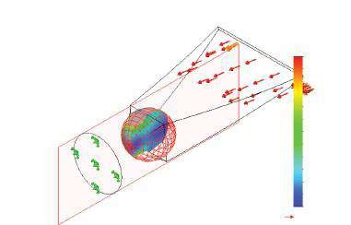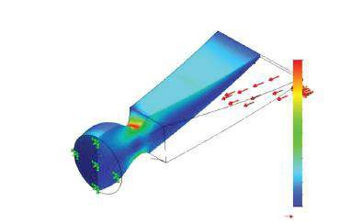

Model name: Chisel1

Study name: Study 1

Plot type: Static nodal stress Stress1

Deformation scale: 24.3562

Mo

del name: Chisel1

Study name: Study

1

Plot ty

pe: Static nodal stress Stress1

De

formation scale: 24.3562

von Mises (N/mm

2

(MPa))

539.5

494.6

449.8

404.9

360.0

315.1

270.2

225.3

180.4

135.5

90.7

45.8

0.9

Yield strength: 620.4

von Mises (N/mm

2

(MPa))

539.5

494.6

449.8

404.9

360.0

315.1

270.2

225.3

180.4

135.5

90.7

45.8

0.9

Yield strength: 620.4

(c) (d)

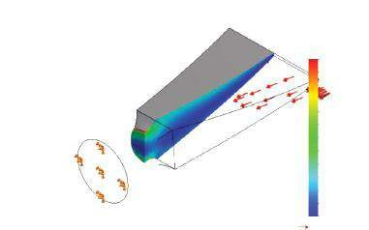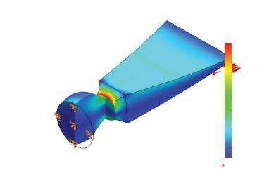

Mo

del name: Chisel1

Study name: Study

1

Plot ty

pe: Static nodal stress Stress1

De

formation scale: 24.3562

Model name: Chisel1

Study name: Study 1

Plot type: Static nodal stress Stress1

Deformation scale: 24.3562

von Mises (N/mm

2

(MPa))

539.5

494.6

449.8

404.9

360.0

315.1

270.2

225.3

180.4

135.5

90.7

45.8

0.9

Yield strength: 620.4

von Mises (N/mm

2

(MPa))

539.5

494.6

449.8

404.9

360.0

315.1

270.2

225.3

180.4

135.5

90.7

45.8

0.9

Yield strength: 620.4

###### Figure 4.21

*Sectioned stress plots. (a) Right plane section with shown contour on the uncut portion of the model; (b) intersecting right plane and sphere sections with shown section entities; (c) union of two planar sections with shown contour on the uncut portion of the model; (d) intersection of two planar sections with no shown contour on the uncut portion of the model.*

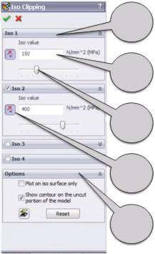

1

1

a

1

b

1

c

2

###### Figure 4.22

*Iso Clipping property manager.*

(a) (b) (c) (d)

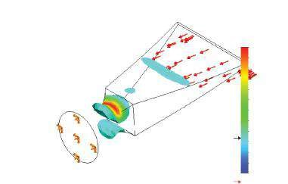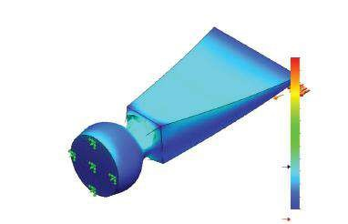

von Mises (N/mm

2

(MPa))

539.5

494.6

449.8

404.9

360.0

315.1

270.2

225.3

180.4

135.5

90.7

45.8

0.9

Yield strength: 620.4

von Mises (N/mm

2

(MPa))

539.5

494.6

449.8

404.9

360.0

315.1

270.2

225.3

180.4

135.5

90.7

45.8

0.9

Yield strength: 620.4

Model name: Chisel1

Study name: Study 1

Plot type: Static nodal stress Stress1

Deformation scale: 24.3562

Element Volume = 90.97%

Model name: Chisel1

Study name: Study 1

Plot type: Static nodal stress Stress1

Deformation scale: 24.3562

Element Volume = 9.03%

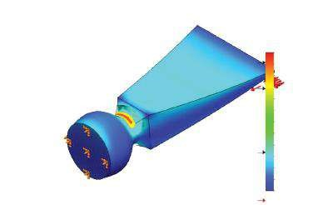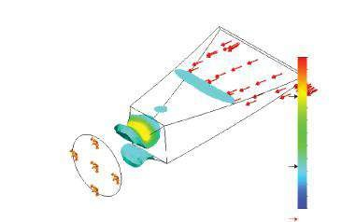

von Mises (N/mm

2

(MPa))

539.5

494.6

449.8

404.9

360.0

315.1

270.2

225.3

180.4

135.5

90.7

45.8

0.9

Yield strength: 620.4

von Mises (N/mm

2

(MPa))

539.5

494.6

449.8

404.9

360.0

315.1

270.2

225.3

180.4

135.5

90.7

45.8

0.9

Yield strength: 620.4

Mo

del name: Chisel1

Study name: Study

1

Plot ty

pe: Static nodal stress Stress1

De

formation scale: 24.3562

Model name: Chisel1

Study name: Study 1

Plot type: Static nodal stress Stress1

Deformation scale: 24.3562

###### Figure 4.23

*Iso Clipping plots. (a) Iso surface with stress values sm aller than 150 MPa; (b) Iso surface with stress values larger than 150 MPa; (c) Iso surface with stress values in between 150 and 400 MPa; (d) Iso surfaces with stress values in between 150 and 400 MPa (yellow-red surface) and smaller than 150 MPa (blue surface).*

**on iso surface only**. If it is selected, the program displays only the surface; otherwise, it displays surfaces, including the iso-surface, that have values larger or smaller than the specified value.

* **Chart Options** (Figure 4.15) – This is the second command accessible through both pop-up menus. It controls the display of the legend in the plot. There are three sub-windows in the **Chart Options** property manager: **Display Options**, **Position/Format** and **Color Options** (Figure 4.24a).
* The **Display Options** sub-window includes four check buttons. The first two of them are **Show min annotation** and **Show max annotation** (1a, Figure 4.24b), which enable either displaying or not the minimum and the maximum values of the plot directly on the plotted **Graphics area** model. The model name, study name, the plot type and the deformation scale are displayed by checking the **Show plot details** (1b, Figure 4.24b). The last

(a) (b)

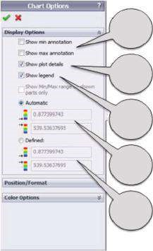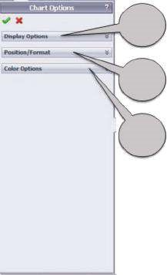

1

1

a

1

b

1

c

1

d

1

e

2

3

(c) (d)

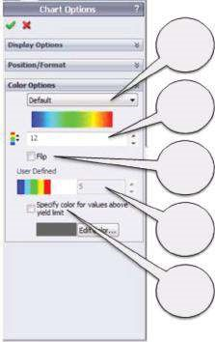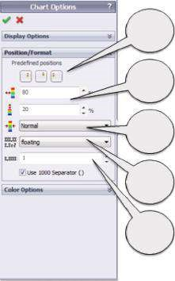

2

a

3

a

3

b

3

c

3

d

3

e

2

b

2

c

2

d

2

e

###### Figure 4.24

*Chart Options property manager. (a) Chart Options window; (b) Default Options sub-window; (c) Position/Format sub-window; (d) Color Options sub-window.*

check button is **Show legend** (1c, Figure 4.24b) and controls either the display or not of the legend. As the final check, the button **Show Min/ Max range on shown parts only** is active for assembled models only; it will not be discussed here. If **Automatic** is selected, the minimum (**Min**,

) and the maximum (**Max**, ) values of the chart automatically define its range (1d, Figure 4.24b). If **Defined** is selected, the minimum (**Min**, ) and the maximum (**Max**, ) values of the chart are specified manually (1e, Figure 4.24b).

* Next is the **Position/Format** sub-window (Figure 4.24c). The first buttons (2a, Figure 4.24c) specify **three predefined positions of the legend** in the plot –  (at the right bottom),  (right, in the middle) and  (at the left bottom). The next two options are alternative options to set the legend’s disposition in the plot (2b, Figure 4.24c). The first one () defines **the horizontal distance** from the left side of the graphics area in percentage of its width, while the second one () sets **the vertical disposition** of the legend. Optionally, if the **Chart Options** property manager is active, the legend can be positioned by right clicking on it and dragging it. This method for positioning the legend is easier, but sometimes it is very hard to displace the legend on one and the same position in different plots, relying only on the precision of our eyes and hands. The last icon on that sub-window (, 2c, Figure 4.24c) sets **the thickness of the legend bar**. The last icons help in defining the type of the display of the numbers, setting **the number format** by choosing among scientific, floating or general types ( , 2d, Figure 4.24c); **the number of decimal places**, which can be up to 16 ( , 2e, Figure 4.24c); and **the use of 1000 separator** or the use of different format for smaller numbers.



* **Color Options** is the third sub-window (Figure 4.24d). It enables choosing the colour palette or defining a new one (3a, Figure 4.24d). We can choose among Default (), Rainbow (), Gray Scale () or

User Defined palette. After that, the number of colours used in the chart should be set (, 3b, Figure 4.24d); the direction of colour mapping can be preserved or flipped (3c, Figure 4.24d), or the User Defined palette (3d, Figure 4.24d) is defined. It is based on up to nine user-defined colours, but no colour interpolation and shading are enabled, that is, only the userdefined colours are used. Finally, the zones, where the von Mises stresses are larger than the yield strength, can either be coloured or not (3e, Figure 4.24d).

Almost the same **Position/Format** and **Chart Options** have been defined through the path Simulation→Options→Default Options→Plot→Color Chart.

The main difference between these two ways is that the options defined through the **Options** window (Figure 4.3a and b) set the properties of all plots; the options defined through the **Chart Options** property manager affect only the active plot. The effect of different **Chart Options** combinations is shown in Figure 4.25.

* **Settings** (, Figure 4.15) – This is the last command in the second group, which is accessible through pop-up menus of the active and non-active plots. It controls the setting of the plot, particularly **Fringe**, **Boundary** and **Deformed Plot** options (Figure 4.26a).

(a) (b)

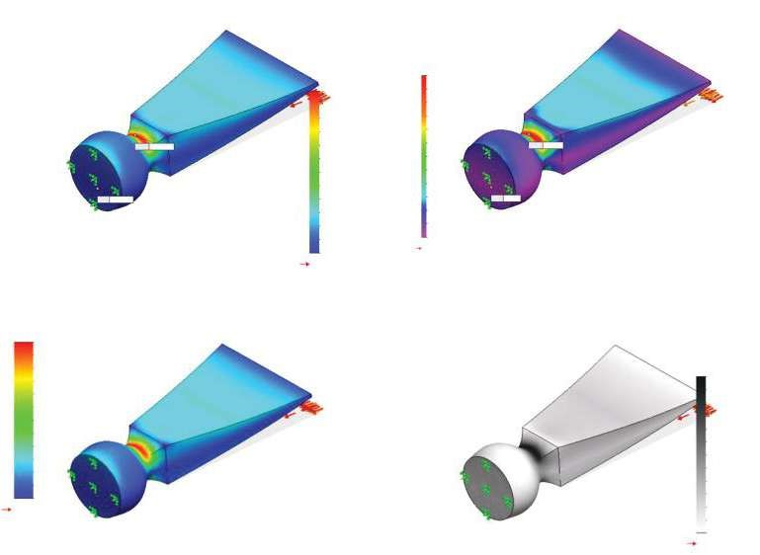

(

c

)

)

(

d

Model name: Chisel1

Study name: Study 1

Plot type: Static nodal stress Stress1

Deformation scale: 24.3562

Model name: Chisel1

Study name: Study 1

Plot type: Static nodal stress Stress1

Deformation scale: 24.3562

von Mises (N/mm

2

(MPa))

von Mises (N/mm

2

(MPa))

540.0

495.0

450.0

405.0

360.0

315.0

270.0

225.0

180.0

135.0

90.0

45.0

0.0

Yield strength: 620.4

5.4e+002

von Mises (N/mm

2

(MPa))

5e+002

5e+002

5e+002

4e+002

4e+002

3e+002

3e+002

2e+002

2e+002

1e+002

9e+001

5e+001

0

5.0e+002

4.5e+002

4.1e+002

3.6e+002

3.2e+002

2.7e+002

2.3e+002

1.8e+002

Max: 5.4e+002

1.4e+002

9.0e+001

4.5e+001

0.0e+000

Yield strength: 6.2e+002

von Mises (N/mm

2

(MPa))

539.5

494.6

449.8

404.9

360.0

315.1

270.2

225.3

180.4

135.5

90.7

45.8

0.9

Yield strength: 620.4

Yield strength 6e+002

Min: 8.8e–001

Max: 539.5

Min: 0.9

###### Figure 4.25

*von Mises stress plot with different chart options. (a) Displayed min/max values; Chart – at the right bottom; Scientific type of numbers; Default palette. (b) Displayed plot details; Chart – at the left bottom; Narrow chart; Floating type of numbers; Rainbow palette. (c) No min/max values; no plot details; Chart – at the right top; Thick chart; General type of numbers; Default palette. (d) No min/max values; Chart – at the left middle; Floating type of numbers; Gray palette.*

* The first sub-window sets **Fringe** options (Figure 4.26b). The choice is among **Point** (coloured point contours), **Line** (coloured line contours) and the colour-filled display either with discrete shading (**Discrete**) or with smooth shading (**Continuous**). The most commonly used display among the above mentioned is **Continuous**.
* The second sub-window sets **Boundary Options** (Figure 4.26c). There could be no boundary edges (**None**), or the plot can be superimposed on the model with displayed boundary edges (**Model**) or be superimposed on the plotted mesh (**Mesh**).
* Finally, we must set the **Deformed Plot Options** (Figure 4.26d). The plot of the deformed shape can or cannot be superimposed on the undeformed shape. The settings of the undeformed shape, particularly its colour and transparency level, are set through that sub-window.

The effect of different **Settings** combinations is shown in Figure 4.27.

* The next, available only in the pop-up menu of an active plot command, is the **Probe** command (, Figure 4.15b). It helps displaying the numerical value at a picked point, drawing a graph and viewing the trend or simply

(a) (b) (c) (d)

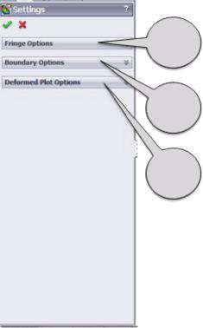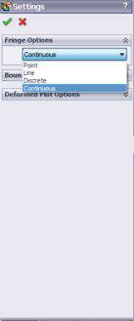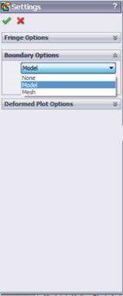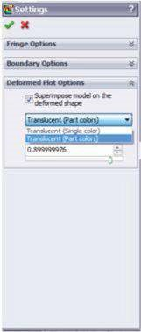

1

2

3

###### Figure 4.26

*Settings property manager. (a) Settings window; (b) Fringe Options sub-window; (c) Boundary Options sub-window; (d) Deform ed Plot Options sub-window.*

(a) (b) (c) (d)

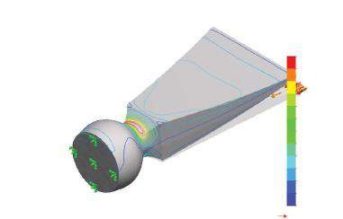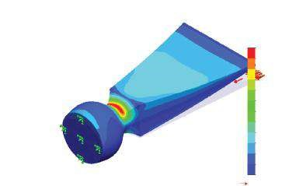

Mo

del name: Chisel1

Study name: Study

1

P

lot type: Static nodal stress Stress1

De

formation scale: 24.3562

Model name: Chisel1

Study name: Study 1

Plot type: Static nodal stress Stress1

Deformation scale: 24.3562

von Mises (N/mm

2

(MPa))

540.0

495.0

450.0

405.0

360.0

315.0

270.0

225.0

180.0

135.0

90.0

45.0

0.0

Yield strength: 620.4

von Mises (N/mm

2

(MPa))

540.0

495.0

450.0

405.0

360.0

315.0

270.0

225.0

180.0

135.0

90.0

45.0

0.0

Yield strength: 620.4

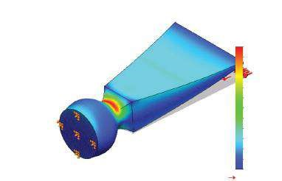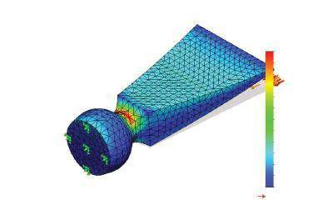

Model name: Chisel1

Study name: Study 1

Plot type: Static nodal stress Stress1

Deformation scale: 24.3562

Mo

del name: Chisel1

Study name: Study

1

Plot ty

pe: Static nodal stress Stress1

De

formation scale: 24.3562

von Mises (N/mm

2

(MPa))

540.0

495.0

450.0

405.0

360.0

315.0

270.0

225.0

180.0

135.0

90.0

45.0

0.0

Yield strength: 620.4

von Mises (N/mm

2

(MPa))

540.0

495.0

450.0

405.0

360.0

315.0

270.0

225.0

180.0

135.0

90.0

45.0

0.0

Yield strength: 620.4

###### Figure 4.27

*von Mises stress plot with different settings. (a) Discrete fringe; no boundary outline; blue undeformed shape. (b) Line fringe; no boundary outline; grey undeformed shape. (c) Continuous fringe; mesh outline; grey undeformed shape; transparency level – 80%. (d) Continuous fringe; model outline; grey undeformed shape; transparency level – 60%.*

saving some of the results. According to the selected **Options** – **At location** or **On selected entities**, there are four or five sub-windows in the **Probe** property manager.

* The first sub-window is **Options** and it enables the selection of the probed parameter (Figure 4.28b). The first option is **At location**. When this option is selected, the next step is to pick a vertex or a node either directly in the **Graphics area** or from the floating **Design tree** at the right side of the **Graphics area**. The results at the picked location are simultaneously displayed in the **Results** sub-window and in the **Graphics area** (Figure 4.28b and c). The displayed X, Y and Z coordinates are the coordinates in the global coordinate system.
* The option **From sensors** is not active now, for no sensor has been defined at the start of the analysis. The sensor definition is useful for timedependent or design analysis, while for static analysis, generally there is no need for sensors.
* The last option is **On selected entity** (). We have chosen to select an edge (Figure 4.28f), but these can also be faces, edges, etc. To display the results, the **Update** button must be clicked (Figure 4.28d). The data for all nodes/elements related to the picked entity are displayed in the **Results** sub-window (Figure 4.28d). Those included in the table properties are defined in the **Annotation** sub-window (Figure 4.28e). When an entity is selected, the **Summary** sub-window is active. It provides some statistics on the data of the selected entity, including the sum (**Sum**), the average value (**Avg**), the **Max** and **Min** values and the **RMS**

(root mean square) value. It must be remembered that in case of *n* values *x Xi* , *RMS* = 1 .

*n*

*x*

*x*

*x*

*n*

(

)

+

+

+

1

2

2

2

2

* The **Report Options** sub-window (Figure 4.28g) provides some options of saving the results. The first option is **Save as Sensor** ( ) and is accessible when a sensor is defined. The second option is **Save** ( ). It saves the probe results in a file of type *.csv, which opens either with a text editor or with MS Excel. By clicking the **Plot** icon (), a graph of the results can be displayed. The generated graph can be saved either as a *.csv file or as a picture file. The options of the graph display are directly set for each separate picture. The X-axis displays a parametric presentation of the nodes in a range [0,1] (Figure 4.28h).



* The **List Selected** command (Figure 4.15b) operates in a similar way as the **Probe** command. Consequently, it will not be discussed in detail.
* **Deformed Result** (, Figure 4.15b) displays the deformed shape of the analysed object.

Before finishing the discussion on the display of the active plot, some words about the **Standard View toolbar** (Figure 4.29) must be said. It is situated at the top of the **Graphics area**. It functions in one and the same way in **SolidWorks** as in **SW Simulation** and helps to orient the model in one of the presented standard views and to manage one or more plots. As far as the standard views are concerned, the icons shown in Figure 4.29 are used.

They are used to preview four different views of the von Mises stress plot in the **Graphics area** (Figure 4.30).

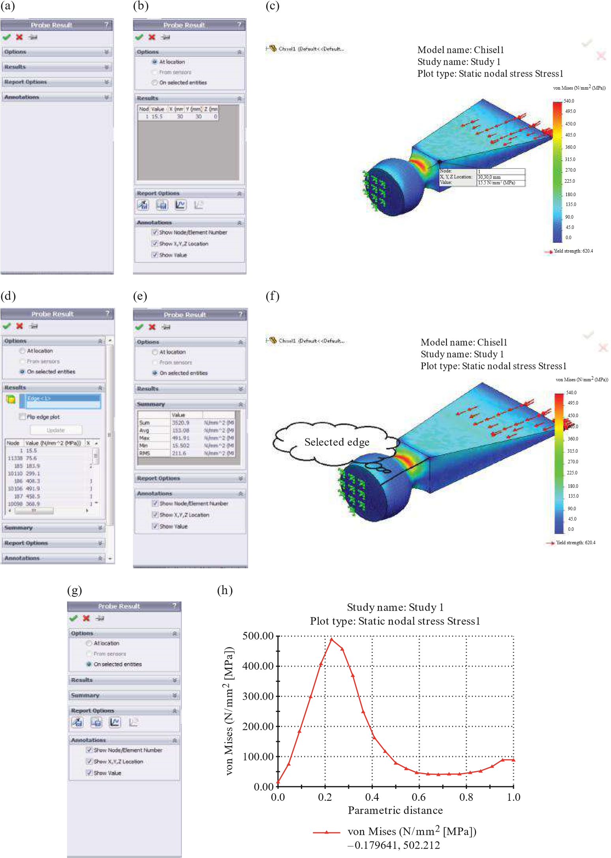

###### Figure 4.28

*Probe property manager. (a) Probe Results window; (b) results at picked location; (c) von Mises stress at picked location; (d) results at selected edge; (e) summary of the results at selected edge; (f) edge picked at the Graphics area; (g) Report Options; (h) graph of von Mises stresses along the selected entity.*

Standard View icons Orientation Viewports

Single view

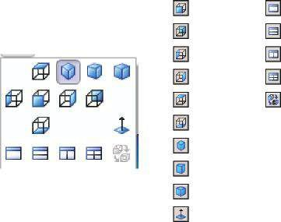

Front

Back

Left

Right

Top

Bottom

Isometric

Trimetric

Dimetric

Normal To

Two view – horizontal

Two view – vertical

Four view

Link views

###### Figure 4.29

*Standard View toolbar.*

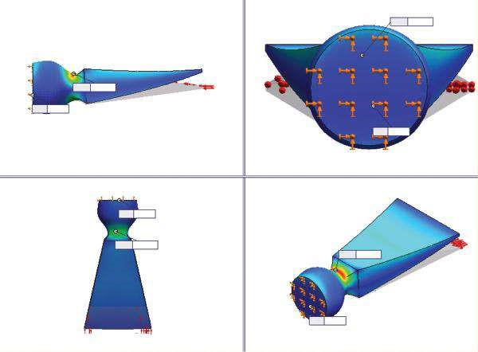

Max: 539.5

Min: 0.9

Min: 0.9

Max: 539.5

Max: 539.5

Min: 0.9

Max: 539.5

Min: 0.9

###### Figure 4.30

*Four standard viewports of von Mises plots.*

The last few commands included in the pop-up menu of the active plot (Figure 4.15b) are **Print**, **Save as** (), **Add to New Folder**, **Copy** and **Delete**. As they are commonly used and familiar commands, their function will not be discussed here. The most specific for them is that they can be related either to the very plot in the **Graphics area** or to some generated graphs, to some lists of results or to results as a whole. The only advice that can be provided here as far as the use of these commands is concerned is to read and to answer carefully all questions set to you by the software, relying on your experience to work with computers.

If we are systematising displacements, both pop-up menus are the same as the ones shown in Figure 4.15. The commands and their options that are accessible through different windows are similar except for those given in the following.

* **Edit Definition** – This command is available in both pop-up menus (Figure 4.15). The first to be discussed is the **Display** sub-window (Figure 4.31a). All available components () are combined in two groups: **Displacements** – X Displacement (**UX**), Y Displacement (**UY**), Z Displacement (**UZ**) and Resultant

Displacement (**URES**); and **Reaction Forces** – X Reaction Force (**RFX**), Y Reaction Force (**RFY**), Z Reaction Force (**RFZ**) and Resultant Reaction Force (**RFRES**) (Figure 4.31b). The directions of the displacements and the reaction forces are parallel to the axes of the global coordinate system. Some displacement plots are given in Figure 4.31c.

* Next, a little bit different command in the pop-up menu is the **Probe** command (, Figure 4.15b). When the active displacement plot shows resultant displacements, a new option in the **Options** sub-window (Figure 4.32b) is accessible. This is the **Distance** button. It enables measuring the distance between any two nodes, picked in the **Graphics area** (Figure 4.32c). The distance after the deformation can be compared to its initial value (Figure 4.32a).

The **Distance** option helps in deformation analysis. The results of the compared distances for the undeformed shape and for the deformed chisel are given in Table 4.5.

The last of all default plots is the **Strain** plot. There are no differences in all applicable commands, except **Edit Definition**. The only differences, as it is reasonable to be expected, are the components () in the **Display** sub-window. They are systematised in four groups: **Normal strain** (**EPSX**: X normal strain; **EPSY**: Y normal strain; **EPSZ**: Z normal strain), **Shear strain** (**GMXY**: shear in the Y direction on the YZ plane; **GMXZ**: shear in the Z direction on the YZ plane; **GMYZ**: shear in the Z direction on the XZ plane), **Principal strain** **E1**: normal strain (1st principal direction), **E2**: normal strain (2nd principal direction), **E3**: normal strain (3rd principal direction), **Strain – total** (**ESTRN**: equivalent strain; and **SEDENS**: strain energy density and **ENERGY**: total strain energy, which are available only in element mode).

Before continuing our explanation, it will be useful to provide some information about what strain is and about the different types of strain. Just like stresses, strains are

(a) (b) (c)

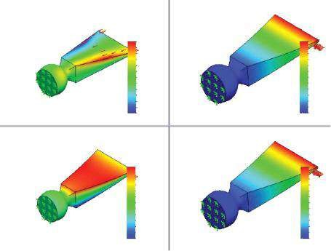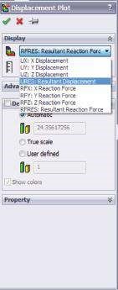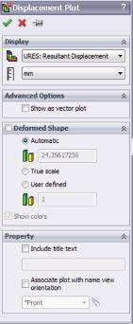

UX (mm)

UZ (mm)

URES (mm)

1.19

1.09

0.994

0.895

0.497

0.398

0.298

0.199

0.0994

1e-030

0.597

0.795

0.696

0.126

0.109

0.0928

0.0764

0.0274

0.011

-0.00536

-0.0217

-0.0381

-0.0544

-0.0708

0.0601

0.0437

UY (mm)

1.19

1.09

0.992

0.893

0.794

0.694

0.595

0.496

0.397

0.297

0.198

0.0988

-0.00047:

0.010

0.008

0.007

0.005

0.003

0.002

0.000

-0.002

-0.003

-0.005

-0.006

-0.008

-0.010

###### Fig u r e 4.31

*Setting displacement properties and displacement plots. (a) Edit Definition panel; (b) Display sub-window; (c) different displacement plots.*

(a) (b)

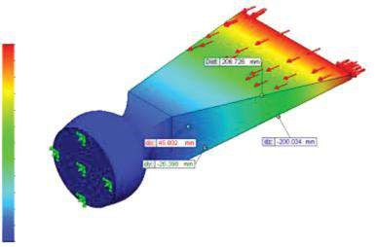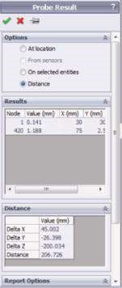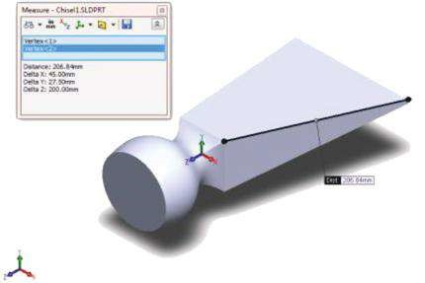

(

c

)

1

2

URES (mm)

1.193

1.084

0.994

0.895

0.795

0.696

0.497

0.597

0.398

0.298

0.199

0.099

0.000

###### Figure 4.32

*Distance calculations in deformed and undeformed chisels. (a) Distance at the undeformed chisel; (b) Options sub-window; (c) distance at the deformed chisel.*

***Table 4.5***

#### Comparison of Few Distances of the Chisel before and after Deformation

|  |  |  |
| --- | --- | --- |
| **Parameters** | **Undeformed Shape** | **Deformed Shape** |
| D elta X = X2 − X1 | 45.000 mm | 45.002 mm |
| Delta Y = Y2 − Y1 | −27.500 mm | −26.398 mm |
| D elta Z = Z 2 − Z 1 | −200.000 mm | −200.034 mm |
| D istance L | 206.840 mm | 206.726 mm |

normal and shear. When Hook’s law is active, the normal stress causes normal strain, whereas shear stress causes shear strain. Normal strains produce dilatations, whereas shear strain produces angle deformations.

If we study a two-dimensional infinitesimal rectangular material element with dimensions *dx* × *dy*, which after its deformation looks a parallelogram (Figure 4.33), we can write

*length* (*AB*) = *dx* and for the adjacent figure



*length* (*ab* ) = *dx* + ∂∂*uxx dx*2 +∂∂*uxy dx*2 =*dx* 1 +2 ∂∂*uxx* +∂∂*uxx* 2 +∂∂*uxy* 2 .

##### Figure 4.33



*y*

*x*

*B*

*A*

*D*

*C*

*a*

*b*

*d*

*c*

*dx*

*dy*

β

α

∂

*u*

*y*

∂

*y*

*u*

*x*

(

*x*

,

*y*

)

*u*

*y*

(

*x*

,

*y*

)

*u*

*x*

(

*x + dx*

,

*y*

)

*u*

*y*

(

*x*

,

*y + dy*

)

*dy*

*dx*

*dx*

*dy*

∂

*u*

*y*

∂

*y*

∂

*u*

*x*

∂

*x*

∂

*u*

*x*

∂

*x*

*Geometric deformation of an infinitesimal material element.*

For small displacement gradients, the expression above is simpler:

*length* (*ab* ) ≈*dx* + ∂*u x dx*

##### ∂x

Thus, the **normal strain** in the x-direction (**EPSX**) of the studied element is

ε*x* = *extension* = *length* (*ab* ) −*length* ( *AB*)

*original length length* ( *AB*)

=*dx* + ∂∂*uxx dx* −*dx*/*dx* = ∂∂*uxx* (EPSX)

##### ∂u y

And the normal strains in the y- and z-directions are ε *y* = (EPSY) and ε*z* = ∂*u z* (EPSZ). ∂*y*

##### ∂z

The **shear strain**, noted as γ*xy*, defines the change in the square angle between AC and AB and is equal to γ*xy* = α + β. Further, based on the geometry, the following can be written:

tan( ∂*u y dx* ∂*u y* ∂∂*uyx dy* = ∂∂*uyx* .

α) = ∂*x* = ∂*x* and tan(β) =

*dx* + ∂∂*uxx dx* 1 + ∂∂*uxx dy* + ∂∂*uyy dy* 1 + ∂∂*uyy*

∂*u x* 1 and ∂*u y*

For small displacement gradients, we have

rotations, tan(α) ≈ α and tan(β) ≈ β. ∂*x* ∂*y*

1, and for small Consequently: α ≈ ∂*u y* , β ≈ ∂*u x* and γ*xy* =α +β = ∂*u y* + ∂*u x* = γ*yx* (GMXY).

##### ∂x ∂y ∂x ∂y

∂*u y* + ∂*u z* = γ*zy* (GMYZ) and γ*xz* = ∂*u x* + ∂*u z* = γ*zx* (GMXZ).

Additionally: γ*yz* =

∂*z* ∂*y* ∂*z* ∂*x*

If we rotate the infinitesimal element around its geometric centre, it is possible to orientate it in a way that there will be no shear stresses along the sides AB and AC. Thus, the square angles will remain square after the deformation, only two perpendicular dilatations, due to the normal stresses that will be observed. These normal stresses are known as principal stresses (**P1**(σ1), **P2**(σ2) and **P3**(σ3)) and are related to the minimum and maximum stretches. The corresponding strains are known as **principal strains** (**E1**(ε1), **E2**(ε2) and **E3**(ε3)).

Equivalent stress (**VON**: *von Mises stress*) is often used in the design work because it allows any arbitrary three-dimensional stress state to be represented by a single positive stress value. Equivalent stress is part of the maximum equivalent stress failure theory used to predict yielding in a ductile material. Equivalent stress is related to the

principal stresses by the equation σ*e* = (σ1 −σ2 )2 +(σ2 −σ3 )2 +(σ3 −σ1 )2 .

2

The von Mises or **equivalent strain** εe (**ESTRN**: Equivalent strain) is computed as

ε*e* = +1 ν (ε1 −ε2 )2 +(ε2 −2ε3 )2 +(ε3 −ε1 )2 , where ν is Poisson’s ratio. 1

A three-dimensional linear elastic solid with loads supplied by external forces *Fi* and through support reactions can be considered to be made up of small cubic elements as shown in Figure 4.34.

The incremental strain energy **dU** for this elemental cube of volume **dV** can be written as

*dU* = 1 {σ ε*x x* +σ ε*y y* +σ ε*z z* +σ ε*x x* +τ*xy* γ*xy* +τ*yz* γ*yz* +τ*zx* γ*zx* }*dV*

2

Integrating the incremental strain energy **dU** over the entire volume **V**, the **total strain energy**, **U** (**ENERGY**: Total strain energy), is obtained:

 *U d* .

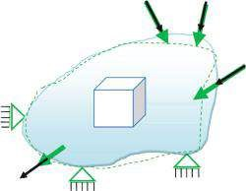

*M*

*n*

*V*

*F*

*n*

*F*

*j*

*M*

*i*

*M*

*j*

*M*

1

*F*

1

*F*

*i*

)

(

T YZ

*z*

T YZ

(

)

(

)

T X Z

*x*

*V*

*y*

*z*

###### Figure 4.34

*Stresses within a linear elastic solid.*

Therefore, the energy stored in a body due to deformation is called **strain energy**.

**Strain energy density** (**SEDENS**: Strain energy density) is a measure of how much energy is stored in small volume elements throughout a material. In other words, it is a scalar function equal to the strain energy per unit volume (Figure 4.35). All these plots are defined by default through

Simulation→ Options→Default Options→ Plot→Default Plots→ Static Study Results

Of course, as has been discussed before, a few more plots can be defined using that path and this will affect all analysis. But it is much easier to open some of the plots suggested by the **Results** panel (Figure 4.14b) of the **SW Simulation analysis tree**. It can be displayed by right clicking on the **Results** folder (Figure 4.14a).

The first command to be discussed in detail is the **Define Factor of Safety Plot** ( ). It has already been briefly discussed, and some plots were given (Figure 4.10).

The **Factor of Safety** property manager opens after clicking on the command line. It consists of three steps, and you can navigate among the windows by clicking the arrows at the top of the property manager ( and , 1, Figure 4.36a).



The first window combines two sub-windows. The first sub-window is titled **Step**

**1 of 3** (2, Figure 4.36a) and the second is **Property** (3, Figure 4.36a). While similar **Property** sub-window has already been discussed (Figure 4.16e and f), the **Step 1 of 3** sub-window is unknown to us. It guides the user through defining the factor of safety criteria and creating the plot. At first, we must choose whether the factor of safety

(a) (b)

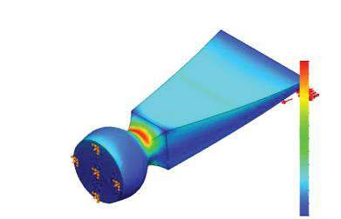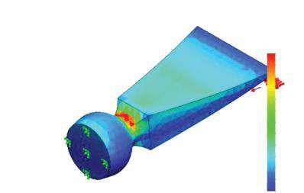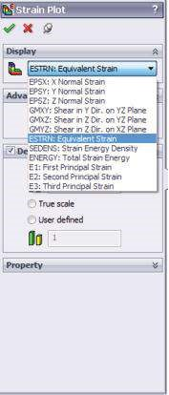

)

(

c

Model name: Chisel1

Study name: Study 1

Plot type: Static strain Strain1

Deformation scale: 24.3562

Model name: Chisel1

Study name: Study 1

Plot type: Static strain Strain1

Deformation scale: 24.3562

ESTRN

ESTRN

1.766

e–

003

1.619

e–

003

1.472

e–

003

003

e–

1.325

003

1.178

e–

1.031

e–

003

8.845

e–

004

7.376

e–

004

e–

004

5.907

4.438

004

e–

2.959

e–

004

004

e–

1.500

006

e–

3.159

2.192

e–

003

2.010

e–

003

1.826

e–

003

1.645

e–

003

1.463

e–

003

1.280

e–

003

1.098

e–

003

9.156

e–

004

7.332

e–

004

5.506

e–

004

3.684

e–

004

1.860

e–

004

3.565

e–

006

###### Fig u r e 4.35

*Equivalent strain plot of the deformed chisel. (a) Display window; (b) equivalent strain – element m ode; (c) equivalent strain – node m ode.*

(a) (b) (c)

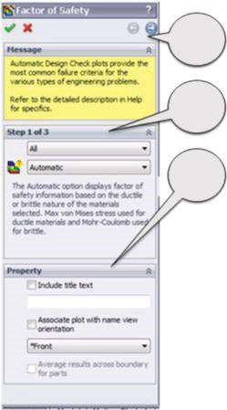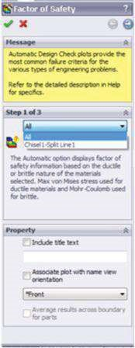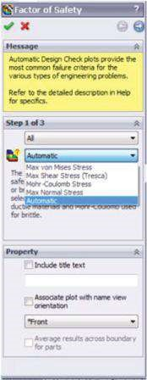

1

2

3

###### Figure 4.36

*Factor of Safety window – Step 1 of 3. (a) Step 1 of 3 window; (b) defining the scope of the safety calculations; (c) defining the m ethod of the safety calculations.*

calculations will include all components of the model (**All**) or only a particular one (, Figure 4.36b). The program considers the stress limit only of selected components; all other components are coloured in grey in the plots. The program cannot calculate the factor of safety of those components whose material has no defined stress limit.

The next step is to select the failure criterion (, Figure 4.36c). The failure criterion predicts the failure of a material subjected to multi-axial state of stresses. Regarding the selected criterion, the safety reserves of the model can be assessed. Materials behave either in a ductile or in a brittle manner depending on the temperature, loading, etc. Until now, a failure criterion applicable to all materials in all cases and conditions has not been developed. That is why you can choose and try a set of criteria that suit you best. Possible choices for solid bodies are **Max von Mises Stress**, **Max Shear Stress (Tresca)**, **Mohr–Coulomb Stress**, **Max Normal Stress** or **Automatic**. Three more criteria, available for composite shells only, **Tsai-Hill Criterion**, **Tsai-Wu Criterion** and **Max Stress Criterion**, will not be discussed now.

The **Max von Mises Stress** criterion is suitable **for ductile materials**. It is based on shear-energy theory, which states that a ductile material starts to yield at a location, where and when the elastic energy of distortion reaches a critical value. At that moment, von Mises stress σ*von Mises* = (σ1 −σ2 )2 +(σ2 −2σ3 )2 +(σ3 −σ1 )2  becomes

equal to the stress limit. In most cases, the yield strength is used as the stress limit. However, the software allows the user to use the ultimate tensile or another stress limit and to compare σ*von Mises* to σ*limit*. The factor of safety at a location is calculated as Factor of Safety (FoS) = σ*lim it* . In the case of pure shear, von Mises stress can be

σ*von Mises*

expressed as σ*von Mises* = 3τ. Hence, failure occurs when τ*max* = 0.577 σ*yield*. As the yield strength is a temperature-dependent property, the temperature of the component is also indirectly considered.

The **Max Shear Stress** criterion, also known as the **Tresca** criterion, is suitable **for ductile materials**. It is based on the maximum shear stress theory, which specifies that a material would flow plastically if σ*Tresca* > σ*limit*. Denoting the greatest of the three principal shear stresses τ*max* and knowing that 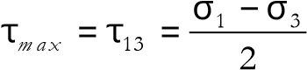 and σ*Tresca* = σ1 − σ3 =

2τ*max*, the Tresca failure criterion can be written as τ*m ax* ≥ σ*lim it* . Hence, the Tresca

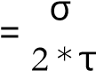*lim it* . 2 factor of safety is Factor of Safety (FoS)

max

The next possible choice is the **Mohr–Coulomb Stress** criterion, which is based on the internal friction theory. This criterion is used **for brittle materials** with different tensile and compressive properties. As brittle materials do not have a specific yield point, the yield strength cannot be used to define the limit stress. Usually the values of limit stress are based on the **Tensile Strength** and **Compressive Strength** of the material. For most of the brittle materials, −σ*Compressive_Strength* ≫ σ*Ten sile_Strength*. This theory predicts failure to occur if σ3 > 0, that is, all normal stresses are tensile, when σ1 ≥ σ*Tensile_limit*; if σ1 < 0, that is, all normal stresses are compressive, when σ3 ≤ − σ*Compressive_limit*; and if σ1 ≥ 0 and σ3 ≤ 0, when σ*Ten sile*σ1_ *lim it* + −σ*Com pressive*σ3 _ *lim it* ≥1. Thus, the Mohr–Coulomb factor of safety is

Factor of Safety (FoS) = 1 .

σ*Ten sile lim it*_ −σ*Com pressive*_*lim it*

+

1

3

σ

σ

The **Max Normal Stress** criterion is based on the maximum normal stress theory. The criterion is **used for brittle materials**. According to the **Maximal normal stress** theory, failure occurs when the maximum principal stress σ1 reaches the ultimate strength of the material for simple tension, that is, this theory predicts failure to occur when σ1 ≥ σ*limit*. Hence, Factor of Safety (FoS) = σσ*lim it*1 .

Before continuing, it is better to systematise and compare these four failure criteria (Table 4.6).

There is one more choice in the set of failure criteria (, Figure 4.36c) and this is the most commonly used **Automatic** choice. Then the program selects the most appropriate criterion in relation to the **Default Failure Criterion** assigned in the **Material** dialog box for each material (Figure 2.30). If no criterion is assigned, the program starts the **Mohr–Coulomb Stress** criterion. For the **Max von Mises Stress** or **Max Shear Stress (Tresca)** criterion, the program uses **yield strength** as allowable stress, while for the **Max Normal Stress** or for **Mohr–Coulomb Stress** criterion, the program uses **tensile strength** as allowable stress.

After selecting the failure criterion, we move to the next window by clicking on the right navigation arrow (1, Figure 4.36a). Thus, **Step 2 of 3** is activated (Figure 4.38). According to the preselected Step 1 criterion, one of the three windows shown in Figure 4.38 opens. The window in Figure 4.38a is active for **Max von Mises Stress**, **Max Shear Stress (Tresca)** and **Max Normal Stress** criteria. The second window (Figure 4.38b)

***Table 4.6***

#### Comparison of the Built-In Failure Criteria

**Failure**

**Criteria Factor of Safety (FoS) Materials and Assumptions**

Max von σ*lim it* Used for It is experimentally proved

|  |  |  |  |
| --- | --- | --- | --- |
| Mises Stress | σ*von Mises* σ*von Mises* = | ductile materials | that for pure shear, the Max von Mises stress criterion provides more accurate results than the |

FoS =

σσ

σ

σ

σ

σ

−

+

−

+

−

(

)

(

)

(

)

1

2

2

2

3

2

3

1

2

2

σ

*limit*

Tresca criterion

Max Shear As a model considering the

Stress FoS = 2 * τ*m ax* plastic material behaviour,

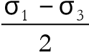(Tresca)Tresca’s criterion is more τ*m ax* =conservative than the Max

von Mises criterion

(Figure 4.37)

Coulomb FoS = 1 Used for brittle It assumes different ultimate strengths of the Mohr–

|  |  |  |  |
| --- | --- | --- | --- |
| Max  Normal  Stress | σ*Tensile lim it*_  FoS =σ*lim it*  σ1 | −σ*Com pressive*_*lim it* | compression  It assumes that the ultimate strength of the material in tension and compression is the same, which is not valid in a lot of cases |
|  | | | |

Stress materials material in tension and

1

3

+

σ

σ

is assigned to the **Mohr–Coulomb Stress** criterion, and the last window (Figure 4.38c) opens after selecting the **Automatic** option. At first, the **Units** of the stress limit must be set (1a, Figure 4.38a; or 2a, Figure 4.38b), and after that the **Stress** limit itself. We can select among the following options: **Yield strength** (recommended for ductile materials); **Ultimate strength** (recommended for brittle materials); or **User defined** (1b,



Tresca

maximal shear

(

)

von Mises

σ

2

σ

1

σ

yield

σ

yield

–σ

yield

–σ

yield

##### Fig u r e 4.37

*Projection of the von Mises and Tresca failure criteria into a plane.*

(a) (b) (c)

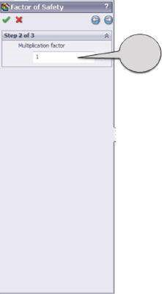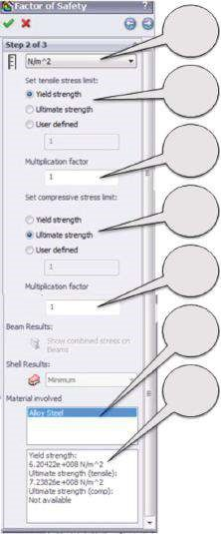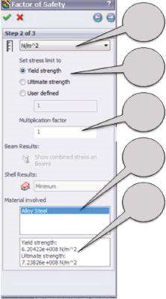

1

a

2

a

3

c

2

b

2

c

2

b*

2

c*

2

d

2

e

1

b

1

c

1

d

1

e

##### Figure 4.38

*Factor of Safety panel – Step 2 of 3. (a) Selecting stress units; (b) selecting stress limit; (c) selecting Multiplication factor.*

Figure 4.38a; or 2b, Figure 4.38b). The **Multiplication factor** is used to multiply the stress limit in order to increase or to lower the limit. Its default value is 1.0 (1c, Figure 4.38a; 2c, Figure 4.38b; or 3c, Figure 4.38c). For the **Mohr–Coulomb Stress** criterion, two different sets for compressive and for tensile stresses are introduced (2b and 2c; 2b* and 2c*, Figure 4.38b). The **Material involved** box shows the material of the component (1d, Figure 4.38a and 2d, Figure 4.38b) and its properties related to the stress limits used by the program to calculate the **Factor of Safety** (1e, Figure 4.38a and 2e, Figure 4.38b).

The last window is **Step 3 of 3** (Figure 4.39a). We can select the **Factor of safety distribution** to plot the distribution of factor of safety (Figure 4.10) or **Areas below factor of safety** and to input a value for the factor of safety to be 5, for example (Figure 4.39a). The **Safety result** box shows the minimum factor of safety based on the selected criterion. The **Factor of safety (FoS)** property manager closes by clicking **OK** (), and the plot is displayed in the **Graphics area** (Figure 4.39b). The program displays all areas with FoS less than the specified value of 5 in **red** (unsafe regions) and regions with higher FoS in **blue** (safe regions).

The analysed chisel is made of steel, which is a ductile material. Nevertheless, if the **Max von Mises Stress** criterion is assigned to the applied material (Figure 2.30), we can vary the criteria and compare the results. Both the **Max von Mises Stress** and **Max Shear Stress** criteria are used for ductile materials. Additionally, the **Automatic** option is added to the set of compared results. All compared results are given in Table 4.7. They confirm the previous statement that the **Max Shear Stress** criterion is more conservative than the **Max von Mises Stress** criterion (Table 4.6).

(a) (b)

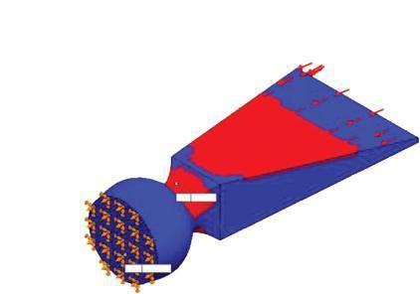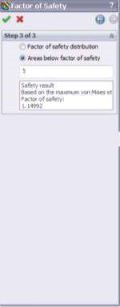

Model name: Chisel1

Study name: Study 1

Plot type: Factor of Safety Factor of Safety1

Criterion: Max von Mises Stress

Red < FOS - 5 <Blue

Min: 1.15

Max: 707.11

##### Fig u r e 4.39

*Factor of Safety panel – Step 3 of 3. (a) Step 3 of 3 window; (b) areas with factor of safety below 5 according to Max von Mises Stress criterion.*

***Table 4.7***

#### Comparison of Minimal FoS Calculated According to Different Criteria

|  |  |  |
| --- | --- | --- |
| **Failure Criterion** | **Min FoS** | **Max FoS** |
| **Max von Mises Stress** | FoSmin = 1.15 | FoSmax = 707.11 |
| **Max Shear Stress** | FoSmin = 1.06 | FoSmax = 627.91 |
| **Automatic** (uses Max von Mises Stress in this case) | FoSmin = 1.15 | FoSmax = 707.11 |

Two more plots can be defined through the **Results** panel (Figure 4.6d) of the **SW Simulation analysis tree**. These are the **Define Design Insight Plot** (Figure 4.11) and the **Define Fatigue Check Plot**. As we have already gotten accustomed to them while discussing the different steps of viewing the results through the **Results advisor**, they will not be discussed here again.

Viewing the results through the **Results** pop-up menu (Figure 4.6c) of the **SW Simulation analysis tree** enlarges extensively the options to systematise them compared to the **Results Advisor** guidance (Figure 4.6d). We have defined three basic plots through

Simulation→ Options→Default Options→Plot→Default Plots

They are **Stress**, **Displacement** and **Strain**.

Their visual presentation is discussed in detail, following the plot options in Figure 4.15 property menus. They include

* **Edit Definition** (Figures 4.16 and 4.18)
* **Animate** (Figure 4.19)
* **Section Clipping** (Figures 4.20 and 4.21)
* **Iso Clipping** (Figures 4.22 and 4.23)
* **Chart Options** (Figures 4.24 and 4.25)
* **Settings** (Figures 4.26 and 4.27)
* **Probe** (Figure 4.28)
* **Deformed Result**
* **Standard View toolbar** (Figures 4.29 and 4.30)

The operation of all these commands is explained in the context of the **Stress** plot.

Some additional explanations, particularly for **Displacement** (Figures 4.31 and

4.32) and **Strain** plots (Figure 4.35), are added.

Finally, the procedure of **Factor of Safety** **(FoS)** calculations and corresponding plots (Figures 4.36, 4.38, and 4.39) are discussed.

|  |
| --- |
| D uring that stage, we learned how to   * View results through the Results pop-up menu of the SW Simulation analysis tree * Change the visual and data properties of the plots * D evelop Factor of Safety (FoS) calculations and generate corresponding plots   We learned some basic theory about   * Strain/Displacement/Stress relations and different types of strain (normal, shear, principal, equivalent strain energy and strain energy density) * Different methods for FoS calculations and compared them |

##### 4.2.3 Results Display through Icons on the SW Simulation Command Bar

The last manner of plotting the results is by using the icons on the **SW Simulation** **command bar** (Figure 4.6b). As we have already gotten accustomed to most of the icons displayed at the command bar, their detailed presentations will be omitted.

By clicking the arrow below the **Results Advisor** icon on the command bar ( , 1, Figure 4.40), a pop-up menu appears. The first icon in that menu directly activated the **Results Advisor** bar (, 2a, Figure 4.40) on the right side of the **Graphics area** to guide us (see Section 4.2.1). Unknown to us is the third command line **New Plot**

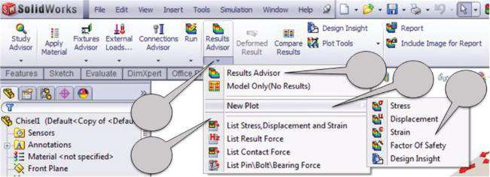

1

2

2

a

2

b

3

###### Figure 4.40

*Results Advisor on SW Simulation command bar.*

(2b, Figure 4.40). It starts a new menu (3, Figure 4.40) that includes all previously discussed commands such as **Stress** ( ), **Displacement** (), **Strain** (), **Factor of Safety** () and **Design Insight** ( ). Selecting any of them, the corresponding property manager opens and the program waits for the input of the plot options. The operation of these property managers has been explained in Chapter 3.



Clicking the **Deformed Result** () controls the overlapping of the plot on the deformed or undeformed shape of the model.

The **Compare Results** command (, Figure 4.40), which is yet to be discussed, allows comparing up to four results in each of the following ways:

* **Comparing the current plot to similar plots from other studies** : This supposes few static studies to be done. There is no limit in the number of the developed studies, but no more than four could be compared simultaneously. We have chosen to develop a second study with different loads. A uniform **Pressure** load of 100 MPa is applied at the head face of the chisel. No loads at the lateral sides of the chisel are considered. After running the analysis, the two studies are ready to be compared.

To do this, all steps given below should be completed:

* Show the compared plot in one of the studies (Figure 4.41a).
* Click the **Compare Results** icon (, Figure 4.40). The **Compare Results** property manager opens.
* Select **Compare selected result across studies** in the **Options** subwindow (Figure 4.41b).
* Select compared studies, no more than four. If there are four or fewer studies with similar plots, they are all selected by default. In our case, **Study 1** and **Study 2** are selected by default (Figure 4.41b).
* Click **OK** ().
* The plots appear in different panes – two horizontal panes in our case (Figure 4.41d). Clicking on a pane displays the associated **Simulation study tree** – **Study 1** for the first pane and **Study 2** for the second. If there are no similar plots in all studies, the program creates temporary plots and removes them after exiting the comparison.
* Click the **Exit Compare** button on the small newly opened **Compare results** window (Figure 4.41c) to close the comparing plots.
* **Comparing multiple plots from the current study** To do this, the steps given below should be completed:
* Click the **Compare Results** icon (, Figure 4.40). The **Compare Results** property manager opens.
* Select the **View multiple results of current study** in the **Options** subwindow (Figure 4.42a). It selects the compared plots, yet no more than four plots can be selected. The first four plots are selected by default. The order of the display by the **Compare Results** property manager plots corresponds to the order in the **SW Simulation analysis tree** (Figure 4.42a).
* Select the **Use settings from this plot for plots of the same type** (Figure 4.42a) and select a plot in the **Study name** to use this plot as a sample and to synchronise temporarily the settings of all plots. This option is not selected for the shown comparison (Figure 4.42b).
* Click **OK** ().

(a) (b) (c)

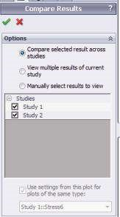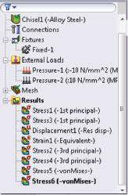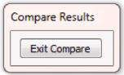

(d)

Model name: Chisel1

Study name: Study 2

Plot type: Static element stress Stress7

Deformation scale: 24.3562

Max: 434.5

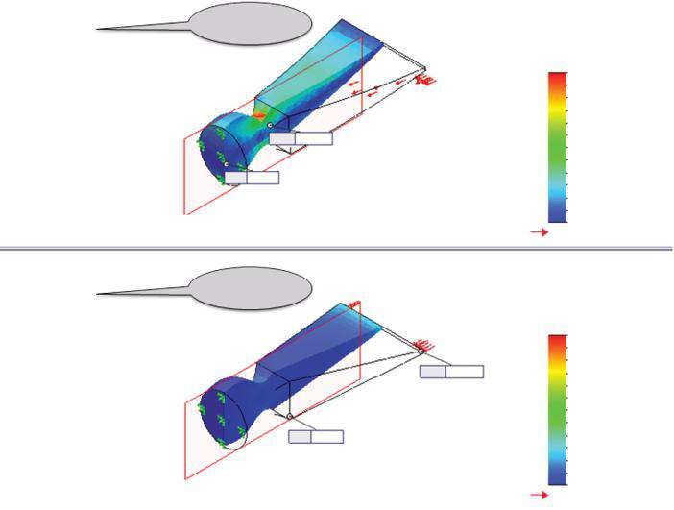

Study 1

Model name: Chisel1

Study name: Study 1

Plot type: Static element stress Stress6

Deformation scale: 24.3562

von Mises (N/mm

2

(MPa))

434.5

398.4

362.2

326.1

290.0

253.8

217.7

181.5

145.4

109.2

73.1

36.9

0.8

Yield strength: 620.4

434.5

398.4

362.2

326.1

290.0

253.8

217.7

181.5

145.4

109.2

73.1

36.9

0.8

Yield strength: 620.4

von Mises (N/mm

2

(MPa))

Min: 0.8

Max: 434.5

Min: 6.7

Max: 104.8

Study 2

Model name: Chisel1

Study name: Study 2

Plot type: Static element stress Stress7

Deformation scale: 24.3562

###### Fig u r e 4.41

*Comparison of similar plots of different studies. (a) Active Stress plot; (b) Exit Compare window; (c) com pared similar plots; (d) cut plots of von Mises stresses.*

* The plots appear in different panes – four panes for four selected plots (Figure 4.42b).
* Click **Exit Compare** (Figure 4.41c) to exit the comparison. • **Comparing arbitrary plots from a different study** The necessary steps are given below:
* Click the **Compare Results** icon (, Figure 4.40).
* Select **Manually select results to view** in the **Options** sub-window

(Figure 4.43a).

* Select up to four compared plots from different studies and type. We select **Displacement** and **Strain** plots of **Study 1** and **Study 2** (Figure 4.43a).
* Optionally, **Use settings from this plot for plots of the same type** can be selected (Figure 4.43a).
* Click **OK** ().

(a) (b)

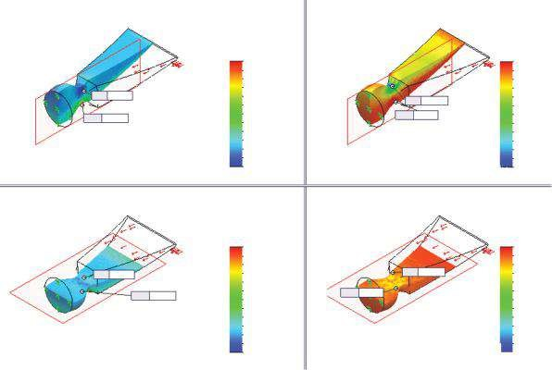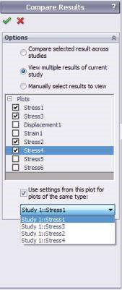

Min: –59.7

Min: –59.7

Min: -494.5

Min: –494.5

31.0

–12.8

–56.5

–100.3

–144.1

–187.9

–231.7

–275.5

–319.3

–450.7

–494.5

–363.1

–406.9

Max: 31.0

Max: 31.0

P1 (N/mm

2

(MPa))

P3 (N/mm

2

(MPa))

31.0

–12.8

–56.5

–100.3

–144.1

–187.9

–231.7

–275.5

–319.3

–450.7

–494.5

–363.1

–406.9

P3 (N/mm

2

(MPa))

290.3

202.8

173.6

86.1

56.9

27.8

–1.4

–30.6

–59.7

144.4

115.3

261.1

232.0

P1 (N/mm

2

(MPa))

290.3

202.8

173.6

86.1

56.9

27.8

–1.4

–30.6

–59.7

144.4

115.3

261.1

232.0

Max: 290.3

Max: 290.3

###### Figure 4.42

*Viewing multiple plots from the current study. (a) Selection of plots; (b) cut plots of maximum and minimum principal stresses for Study 1.*

(a) (b)

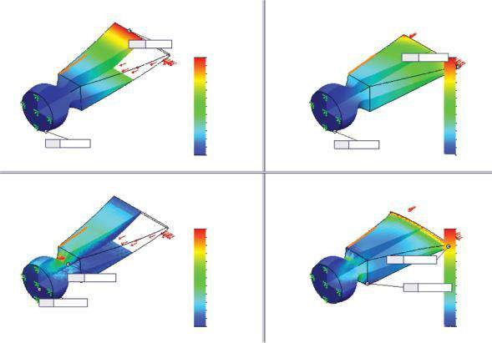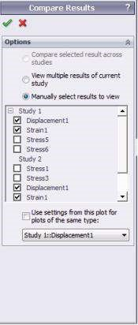

Max: 1.19

Max: 0.0554

URES (mm)

EST RN

EST RN

0.000426

0.000393

0.000359

0.000326

0.000293

0.00026

0.000226

0.000193

0.00016

0.000127

9.36e-005

6.04e-005

2.72e-005

0.00177

0.00162

0.00147

0.00133

0.00118

0.00103

0.000884

0.000738

0.000591

0.000444

0.000297

0.00015

3.16e-006

Max: 0.00177

Max: 0.000426

Min: 3.16e-006

Min: 2.72e-005

URES (mm)

1.19

0.0554

0.0507

0.0461

0.0415

0.0369

0.0323

0.0277

0.0231

0.0185

0.0138

0.00923

0.00461

1e-030

1.09

0.994

0.895

0.795

0.696

0.597

0.497

0.398

0.298

0.199

0.0994

1e-030

Min: 1e-030

Min: 1e-030

###### Figure 4.43

*Comparison of arbitrary plots from different studies. (a) Selection of plots; (b) angle cut plots of displacem ent and equivalent strain for Study 1 (in the left) and for Study 2 (in the right).*

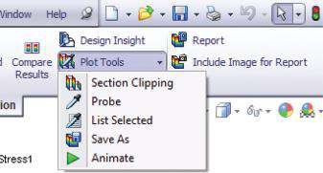

###### Figure 4.44

*Plot Tools pop-up menu.*

* The plots appear in different panes (Figure 4.43b).
* Click **Exit Compare** (Figure 4.41c).

If a plot is active, clicking **Plot Tools** (, Figure 4.44) opens a pop-up menu that combines some of the previously discussed commands for defining plot properties. They are **Section Clipping** (), **Probe** (), **Animate** () as well as **List Selected** () and **Save As** ().

Clicking on the **Report** icon (, Figure 4.44) opens the known **Report Options** panel (Figure 4.4b).

**Include Image for Report** (, Figure 4.44) inserts the image into the report through the opened **Insert Image** property manager (Figure 4.45).

* The **Image Type** sub-window (Figure 4.45a) enables us to choose between two options. Our choice can be either the **Current View**, which inserts the current plot of the model, mesh or results, viewed in the **Graphics area**, or the **Image file**, which inserts an already existing picture of *.jpg, *.bmp or *.gif

(a) (b) (c)

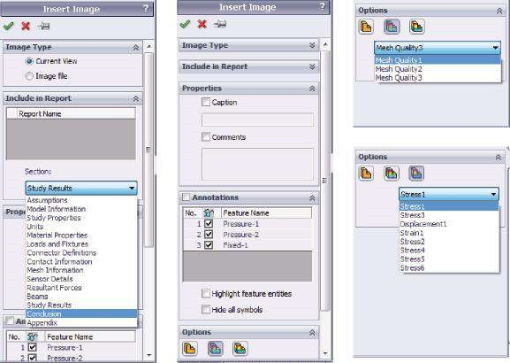

###### Fig u r e 4.45

*Insert Image property manager. (a) Image Type and Include in Report sub-windows; (b) Properties and Annotations sub-windows; (c) Options sub-window.*

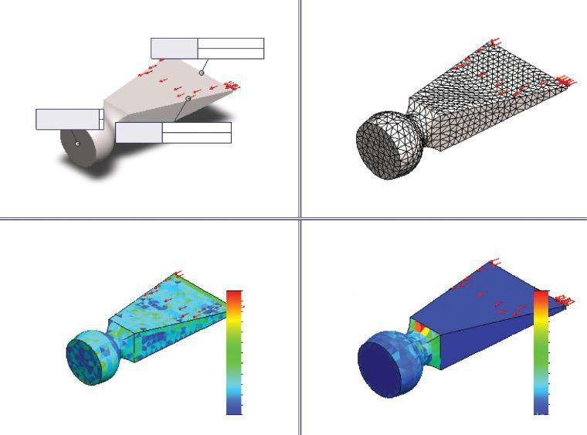

Aspect Ratio

Pressure-2:

Pressure:

10

N/mm^2 (MPa

)

Pressure-1:

Pressure:

Fixed-1:

Model name: Chisel1

Study name: Study 1

Plot type: Mesh Mesh Quality1

Model name: Chisel1

Study name: Study 1

Plot type: Mesh Mesh Quality2

Model name: Chisel1

Study name: Study 1

Plot type: Jacobian Ratio Element Distribution Mesh Quality3

Fixed Geometry:

–10 N/mm^2 (MPa)

3.939e+000

3.699e+000

2.263e+000

2.023e+000

1.784e+000

1.545e+000

1.305e+000

1.006e+000

3.460e+000

3.221e+000

2.981e+000

2.742e+000

2.502e+000

Aspect Ratio

2.243e+00

0

1.518e+00

0

1.414e+00

0

1.311e+00

0

1.207e+00

0

1.104e+00

0

1.000e+00

0

1.932e+00

0

1.829e+00

0

1.725e+00

0

1.621e+00

0

2.139e+00

0

2.036e+00

0

###### Figure 4.46

*Different views of the meshed chisel.*

types saved anywhere in our computer. If the state of the model changes, during the analysis, the embedded pictures do not update automatically.

* The **Include in Report** sub-window (Figure 4.45a) enables us to choose the report and the exact section where the image is to be inserted.
* The **Properties** sub-window (Figure 4.45b) handles the properties of the inserted picture, such as **Caption** or **Comments**.

The next two sub-windows are accessible only if the **Current View** option is selected at the beginning.

* The **Annotations** sub-window (Figure 4.45b) handles the viewing of the loads (Pressure – 1 and Pressure – 2), fixtures (Fixed – 1) or connectors (see the plot at the top left of Figure 4.46). The viewed information can include the type and value (**Feature Name**), the effected entities (**Highlight feature entities**) and the symbols that denote the feature (**Hide all symbols**).
* The **Options** sub-window (Figure 4.45c) helps to select the type of the plot.
* The **Model View** (, Figure 4.45c) captures the current model view and displays it in the **Graphics** area (the plot at the top left, Figure 4.46).
* The **Mesh View** (, Figure 4.45c) option is available only if the model is meshed. There are three views of the mesh (Figure 4.46): **Mesh Quality 1** – dis plays the meshed model (the plot at the right top); **Mesh Quality 2** – displays the Aspect ratio (the plot at the left bottom); **Mesh Quality 3** – dis plays the Jacobian Ratio Element Distribution (the plot at the right bottom).
* **Result Plots** (, Figure 4.45c) can be activated only if there are any results. It allows selection of a generated result plot, which is included in the selection list.
* To see the plots in the **Graphics area**, the **Activate** button must be clicked.

•

The

**Insert Image**

property manager closes by clicking

**OK**

(



).

In this section, we used the icons on the **SW Simulation command bar** (Figures 4.6b and 4.40) to systematise and display more results.

We discussed the three different ways of visually comparing the results using the **Compare Results** command:

* **Comparison of similar plots of different studies** (Figure 4.41)
* **Viewing multiple plots from the current study** (Figure 4.42)
* **Comparison of arbitrary plots from different studies** (Figure 4.43)

We deepen our knowledge of how to insert an image in a report using the **Insert Image** property manager (Figure 4.45). The options of that command allow the insertion of either a **Current View** (Figure 4.45a) from the **Graphics area** or an existing **Image file** (Figure 4.45a) by browsing the directories of the computer.

|  |
| --- |
| D uring that stage, we used the icons on the SW Simulation command bar to display some more plots of viewing the results. We learned how to   * Compare up to four plots of one and the same or of different studies ( ) * Insert a current plot or an already saved image file in the report ( ) * Superimpose the plot either over the undeformed or over the deformed shape of the body in an easier manner ( ) |

### 4.3 LISTING THE RESULTS OF THE ANALYSIS

While plotting the results provides better view of the component distribution, their listing provides a higher precision. The program presents the lists in tables. The main weakness of the listed results is their quantity. Therefore, sometimes it is very difficult for these data to be sorted and analysed.

Without any concerns about the type of the analysis, we can **list mesh properties** using the **Probe** property manager () and clicking the **Save** icon () on the **Report Options** sub-window. Based on selecting the **Advanced Option** sub-window mode, element or node, the program saves a table including information on the number of elements/nodes and its global coordinates.

With regards to focusing on the static studies of a single body, there are a few commands with regards to listing the results: to list stress values, to list displacements, to list strain and to list the resultant force. All these commands can be started either from the pop-up **Results** menu from the **SW Simulation** analysis tree (Figure 4.47a) or from the pop-up **Results Advisor** menu from the **SW Simulation command bar** (Figure 4.47b).

All files generated by the program lists are either **MS Excel files** (*.csv) or **text files** (*.txt). The first are not typical MS Excel files, and it is not possible to directly filter the data, generate charts, etc.; but they are easy to be imported in the SW environment. The text files can be opened easily with any text editor, as well as with the MS Excel software; thus, they behave as typical MS Excel files and their data are easy to be sorted, filtered, etc.

The command to be discussed here is the **List Stress, Displacement and Strain** command (, Figure 4.47b). It opens the **List Results** property manager (Figure 4.48a), which includes four sub-windows: **Quantity**, **Component**, **Advanced Options** and **List Set**.

* The first to be explained is **how to list stresses**. We have to follow the stages stated in the following:
* Check **Stress** in the **Quantity** sub-window (Figure 4.48b).
* Select the listed component (, Figure 4.48b) from the provided list. If you choose a directional stress, such as normal or shear stress, you can pick an alternative reference entity in the **Advanced Options** sub-window. Otherwise, this window is not accessible. Next is to set the **Units** () of the list. **Plot Step** () sets the step number at which the selected results are to be listed. Thus, it is not active for static studies.
* The first optional stage in the **Advanced Options** sub-window (Figure 4.48d) is picking a reference entity (), if appropriate. As has been explained, it can be a plane, an axis or a newly defined coordinate system. If no reference entity is picked, the program uses the global coordinate system to orientate the stresses. By selecting **Nodes**, the software is

(a) (b)

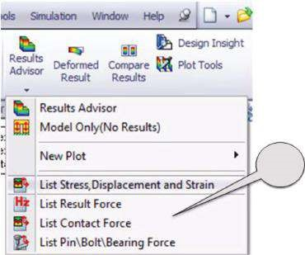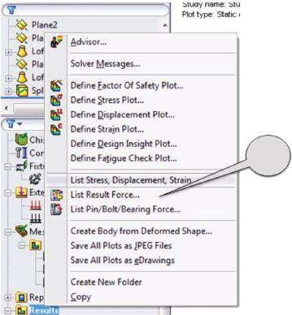

1

2

#### Fig u r e 4.47

*Different ways to start a list command. (a) Pop-up Results menu; (b) pop-up Results Advisor menu.*

(b) (c) (d)

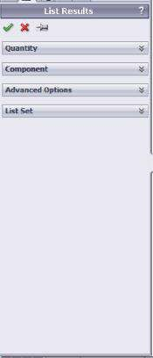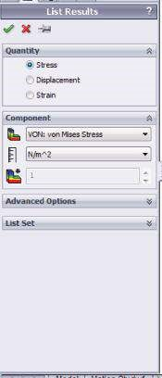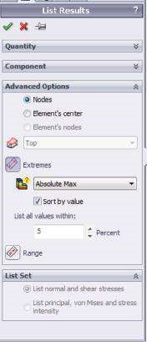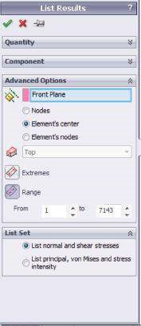

#### Figure 4.48

*List Results property manager – stresses. (a) List Results property manager – basic view; (b) Quantity and Component sub-windows for creation of stress list; (c) Advanced Options sub-window for extreme stress list; (d) Advanced Options and List Set sub-windows for range stress list.*

being informed to list the selected stress in the nodes, while selecting the **Element’s center** lists the calculated stresses for the element mode. This means that each element value is an averaged value of the stresses fixed to the element nodes. The **Element’s nodes** option is available only if **Range** is selected.

* The next **Advanced Options** choice is **Extremes** ( ) or **Range** () values to be included in the list. Checking **Extremes** ( , Figure 4.48c) searches for extreme values, and if **Sort by value** is selected, it sorts the list according to the following criteria (): **Absolute Max**, **Algebraic Max** and **Algebraic Min**. **List all values within** shortens the list by including only these values, which are in the range, defined by 5% (by default) tolerance of the extreme value. **Range** (, Figure 4.48d) lists the values within a range, specified by the lowest and the highest node/ element numbers. The type of the listed data in the **Range** mode is introduced by checking the **List Set** sub-window (Figure 4.48d). The program generates either a **List of normal and shear stresses** or lists of principal stresses, von Mises stresses and stress intensity.



* The adjusted list is generated after clicking **OK** ().
* The **list of displacements** can be generated as follows:
* Our first choices are the **component** (), from the displacement list, and the **units** () (Figure 4.49a). The rules that must be observed are similar to those for the generation of stress list.
* **Advanced Options** (Figure 4.49a), particularly **reference entity** (), **Extremes** () and its adjusting options, obey the same rules as the

(b) (c) (d)

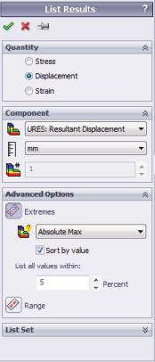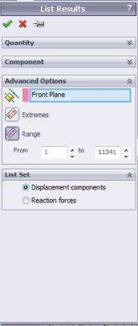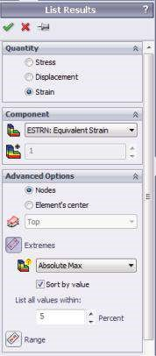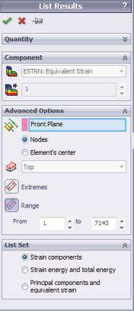

#### Figure 4.49

*List Results property manager – displacements. (a) Quantity, Components and Advanced Options sub-windows for extreme displacement list; (b) Advanced Options and List Set subwindows for range displacement list; (c) Quantity, Components and Advanced Options subwindows for extreme strain list; (d) Advanced Options and List Set sub-windows for range strain list.*

corresponding options for stresses. As only the displacements of the nodes are calculated, there is no element mode. Checking the **Range** () sets the range of the list based on the numbers of the nodes. It relates the **List Set** (Figure 4.49b) options **Displacement components** or **Reaction forces** lists.

* The displacement list will be generated after clicking **OK** (), and the corresponding tables for **displacement components** (UX, UY, UZ, UREZ) and for **reaction force components** (RFX, RFY, RFZ, RFREZ) are shown in Figure 4.50.
* Compared to the lists of stresses and of displacements, the generation of **list of strain** differs in the following:
* The list of the **components** () and the **units** () (Figure 4.49c).
* **Nodes** and the **Element’s center** handled through **Advanced Options** (Figure 4.49c and d) are available in **Extremes** () and in **Range** () lists.
* Generation of **Range** () lists is again directly related to the options in the **List Set** sub-window (Figure 4.49d). These options are as follows: **Strain components**, which if selected lists the normal and the shear strain components with respect to the selected reference geometry, if any; and **Strain energy and total energy**, which lists strain energy density and total strain energy and **Principal components and equivalent strain**.
* The **List Results** property manager closes and the list command is executed after clicking **OK** ().

(b)

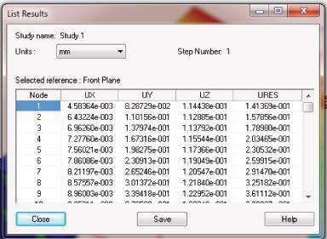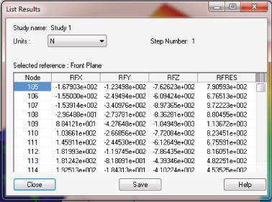

#### Fig u r e 4.50

*Displacement range tables. (a) Displacement components table (mm); (b) reaction force components (N).*

The next command to be explained is the **List Result Force** (, Figure 4.47a or , Figure 4.47b). Clicking its icon opens the **Result Force** property manager (Figure 4.51a), which combines five sub-windows:

• The **Options** sub-window (Figure 4.51b) limits our choice to **Reaction force**, **Free body force** and, inaccessible for that study, **Remote load interface force Contact/Friction force**. Selecting the **Reaction Force** lists X, Y, Z components and the magnitude of the force for selected entities or for the entire model. Checking the **Free body force** lists free body forces due to the action of external loads, restraints, contacts, etc. at all preselected entities, such as faces, edges, etc.

(a) (b) (c) (d) (e)

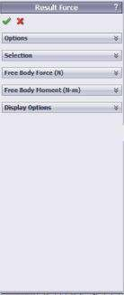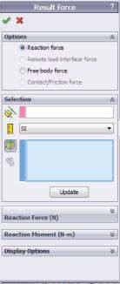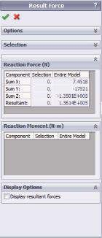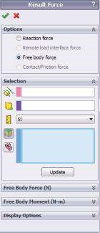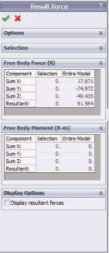

#### Fig u r e 4.51

*Result Force property manager. (a) Result Force window; (b) Options and Selection subwindows – Reaction force selected; (c) Reaction Force, Reaction Moment and Display Options sub-windows; (d) Options and Selection sub-windows – Free body force selected; (e) Free Body Force, Free Body Moment and Display Options sub-windows.*

(a) (b)

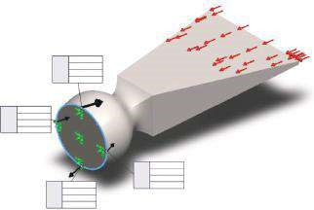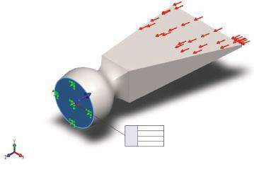

FX:

FY:

FZ:

FRes:

N

7.45

–1.75e+004 N

–1.35e+005 N

N

1.36e+005

FX:

FY:

FZ:

FRes:

FX:

FY:

FZ:

FRes:

1.79e+003

N

223

N

–6.44e+003 N

N

6.69e+003

FX:

FY:

FZ:

FRes:

–19 N

–2.87e+003 N

1.05e+004

N

1.09e+004

N

FX:

FY:

FZ:

FRes:

–1.7e+003 N

186

N

–6.38e+003 N

6.6e+003

N

N

1.09

–6.2e+003 N

–2.45e+004 N

2.52e+004 N

Isometric

#### Fig u r e 4.52

*Free body force diagrams. (a) Selected root face entity; (b) checked Display Options.*

* As the options in the **Selection** sub-window related to the generation of **Reaction force** (Figure 4.51b) and **Free body force** (Figure 4.51d) lists are almost similar, they will be discussed simultaneously. We can define a new **reference entity** – plane, axis or coordinate system () or a **vertex or reference point for location of the moment** (). After that, we select the output **units** (). The list of picked **entities** is displayed in the blue window. They can be faces, edges or vertices () or components () for which the forces are to be listed. Finally, the **Update** button must be clicked to update newly selected properties. Generally, the components for any selected entity are displayed, and their values and the value of the magnitudes are directly written besides the model (Figure 4.52a).
* **Reaction Force (N)** and **Free Body Force (N)** (Figure 4.51c and e) display the components (**Sum X, Sum Y and Sum Z**) and the magnitudes

(**Resultant**) of the reaction moment/free body force of the selected entities or of the entire part (Figure 4.52).

* **Reaction Moment (N-m)** and **Free Body Moment (N-m)** (Figure 4.51c and e) display the components and the magnitude of the reaction moment/free body moment of the selected entities or of the entire model.
* When selected, **Display Options** (Figure 4.51c and e) displays the resultant force/free body force vector as a black arrow (Figure 4.52b).
* At the end, click **OK** () to close the property manager.

In this section, we generated different lists of results. All useful icons can be reached in two ways:

* **Through the SW Simulation analysis tree:**

Results (right click) → List Stress, Displacement, Strain/List Result Force*…*

* **Through the SW Simulation command bar:**

Results Advisor (click the arrow below) → List Stress, Displacement, Strain/List Result Force*…*

We can save the lists in two different interchangeable file formats – *.csv and *.txt. Each format supposes different ways to filter and systematise the data in tables and diagrams that are suitable for future analysis (Figures 4.50 and 4.52).

We explained in details the operation of

* **List Results property manager** (Figure 4.49)
* **Result Force property manager** (Figure 4.51)

|  |
| --- |
| We learned how to generate and save different lists of results. All the lists can easily be opened and operated by different software packages, including commonly used programs of the MS O ffice package and text editors Wordpad and Notepad. We learned how to filter and arrange automatically the useful data. We learned how to create and view   * Lists of stresses * Lists of displacements * Lists of strain * Lists and diagrams of reaction forces and moments * Lists and diagrams of free body forces and moments |

### 4.4 DRAWING GRAPHS OF THE ANALYSIS RESULTS

There are some different graphs that the program generates while running static analysis. They can be classified in two major groups:

* **Convergence graphs** – these graphs present the convergence of the calculation process. They were partially discussed in Chapter 3 (Figure 3.16a). They are the program’s visual feedback on the speed and convergence of the calculations. For example, to fasten the calculations, we can either set a higher threshold or decrease the number of iterations. If an adaptive method is selected and calculations are successful, a new command line is accessible in the **Results** pop-up menu – **Define Adaptive Convergence Graph** (Figure 4.53a). Clicking on it opens the **Convergence Graph** property manager, which includes only one sub-window and five checks.

Optional selections for the **p-adaptive method** are as follows (Figure 4.53b):

* Maximum von Mises Stress (Figure 4.54a)
* Maximum Resultant Displacement (Figure 4.54b)
* Total Strain Energy (Figure 4.54c)
* % Change in Global Criterion (Figure 4.54d)
* Degrees of Freedom (DOF) (Figure 4.54e)

The first three criteria for studying the convergence when the p-adaptive method is used generate graphs for the maximum values of the selected property in each iteration loop for the entire model. The fourth option of the set generates a graph for the global criterion of the p-adaptive method. This criterion is specified before running the analysis in the **Options** panel (Figure 4.1a). It can be either the total strain energy, or the RMS of the resultant displacement or

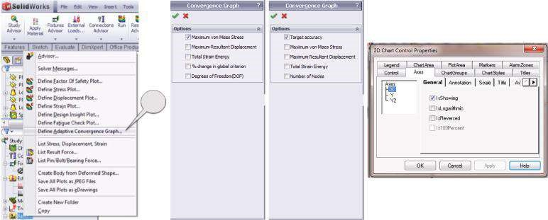

1

#### Fig u r e 4.53

*Menus for defining a convergence creation of adaptive convergence graphs.*

the RMS of von Mises Stress. In our case, the criterion is **Total Energy Strain**. The fifth option generates the graph of the DOFs versus the number of loops. It must be reminded that in the p-adaptive method, the number of DOFs increases (Figure 2.25b).

Optional selections for the **h-adaptive method** are (Figure 4.53c)

* Target accuracy
* Maximum Resultant Displacement
* Total Strain Energy
* % Change in Global Criterion
* Number of Nodes

The unknown convergence graphs that the software generates if the h-adaptive method is selected are **Target accuracy**, which draws the graph of accuracy compared to the target value set at the start of the calculations, and **Number of Nodes**, as it increases throughout the calculations.

* The properties of each of these graphs can be adjusted through the **2D Chart Control Properties** window (Figure 4.53d). Generally, the horizontal axis gives the number of loops and the vertical axis gives the values. If more than one option is selected, the vertical axis is normalised to unity.
* If before running the analysis, the **Trend Tracker** () is selected, additional graphs of the model properties or simulation results versus the number of loops are generated (Figure 4.55). The shown graphs are for the h-adaptive method with target accuracy of 99% reached within three iterations.
* **Probe graphs**  – these are the graph results along any linear entity. The graphs are generated after clicking the **Plot** icon () from the **Probe** property manager (Figure 4.28). It generates a 2D graph of the preselected results. The horizontal values, which correspond to the locations of nodes along the edge, are normalised to 1. While drawing the graphs, the program assumes linear interpolation between equal distances or between probed locations, or between listed values. For example, the UZ displacements along edge 1 are larger at the head of the chisel and even turn to be negative at the nodes closer to the root (Figure 4.56b). For edge 2, the theory calculates uniform values along the

(a) (b)

1.00

542,000,000.00

543,000,000.00

544,000,000.00

545,000,000.00

546,000,000.00

547,000,000.00

548,000,000.00

549,000,000.00

1.20

1.40

1.60

Loop number

Loop number

p-Adaptive convergence graph

V

alue (m)

p-Adaptive convergence graph

1.80

2.00

Va

lue (N/m

2

)

1.00

0.00

0.01

1.20

1.40

1.60

1.80

2.00

Global criterion: Total strain energy change <1% Global criterion: Total strain energy change <1%

Maximum von Mises stress Maximum resultant displacement

1.39446, 5.48906e+008 1.2087, 0.0105381

(c) (d)

1.00

14.21

0.03

0.04

14.22

14.23

1.20

1.40

1.60

Loop number

p-Adaptive convergence graph

V

alue (N-m)

V

alue

1.80

2.00

1.00

1.20

1.40

1.60

Loop number

p-Adaptive convergence graph

1.80

2.00

Global criterion: Total strain energy change <1% Global criterion: Total strain energy change <1%

Total strain energy % change in global criterion 0.852071, 14.2235 1.42029, 0.0402691

1.00

1.20

1.40

1.60

Loop number

1.80

2.00

p-Adaptive convergence graph

200,000.00

210,000.00

220,000.00

230,000.00

240,000.00

250,000.00

260,000.00

V

alue

(

e

)

Global criterion: Total strain energy change <1%

Degrees of freedom (DOF)

0.822581, 262,422

#### Fig u r e 4.54

*Convergence graphs for p-adaptive method. (a) Maximum von Mises stress; (b) maximum resultant displacem ent; (c) total strain energy; (d) % change in global criterion; (e) degrees of freedom (DOF).*

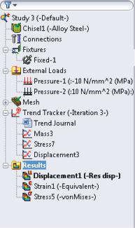

1

544.00

1.20

1.19

545.00

546.00

547.00

548.00

549.00

550.00

551.00

552.00

553.00

2

Iteration

3

von Mises (N/mm

2

[MPa])

URES (mm)

von Mises

0.578947, 552.357

1

2

Iteration

3

URES

2.67416, 1.1994

a

)

(

(

b

)

(

c

)

#### Fig u r e 4.55

*Trend Tracker graphs for h-adaptive m ethod. (a) SW Simulation analysis tree with active Trend Tracker; (b) stress Trend Tracker graph; (c) displacem ent Trend Tracker graph.*

edge, while the experiments and our analysis show larger positive values at both ends and smaller displacements at the middle (Figure 4.56c). These values correspond to higher compressive stresses in the ends.

We drew some graphs that can ease the analysis of the results. We furthered our knowledge of **Convergence graphs**, which helps us assess the calculation process. We strengthened our ability to generate **Probe graphs** along an edge for a preselected displacement.

(a)

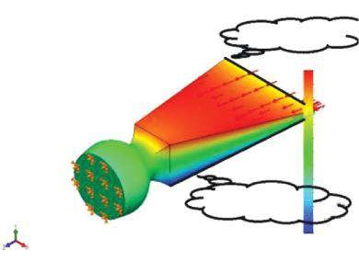

Selected edge 2

Selected edge 1

Model name: Chisel1

Study name: Study1

Plot type: Static displacement Displacement1

Isometric

1.255

e–

001

1.092

e–

001

8.201

e–

002

0.144

e–

002

6.000

e–

002

4.372

e–

002

2.736

e–

002

1.100

e–

002

–5.361e–003

–2.172e–002

–3.808e–002

–5.447e–002

–7.080e–002

02

(mm

)

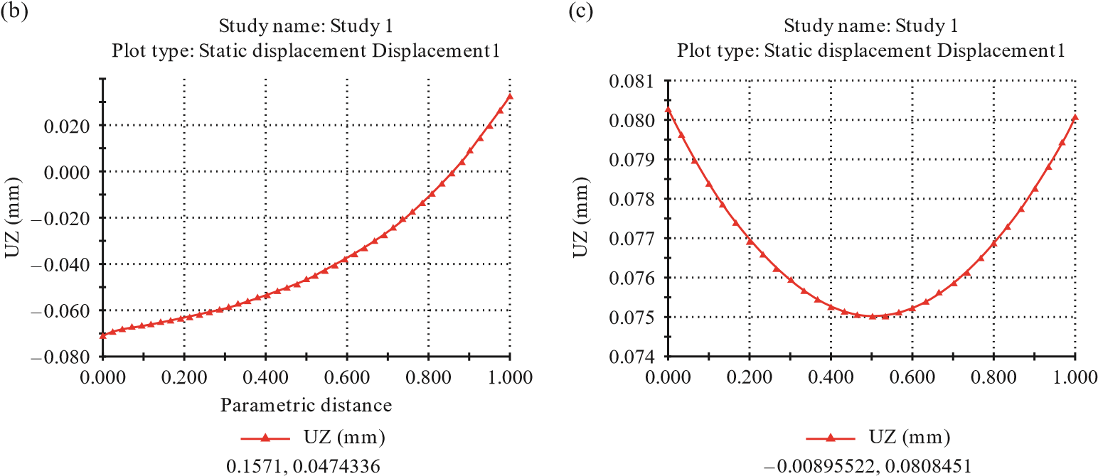Parametric distance

#### Fig u r e 4.56

*Probe UZ displacem ent graphs. (a) View of the chisel; (b) probe graph of edge 1; (c) probe graph of edge 2.*

|  |
| --- |
| We learned how to generate graphs:   * **Convergence graphs** – to ease the assessment of the accuracy, computer resources and the speed of the calculations * **Probe graphs** – to view displacement values along a selected linear entity |